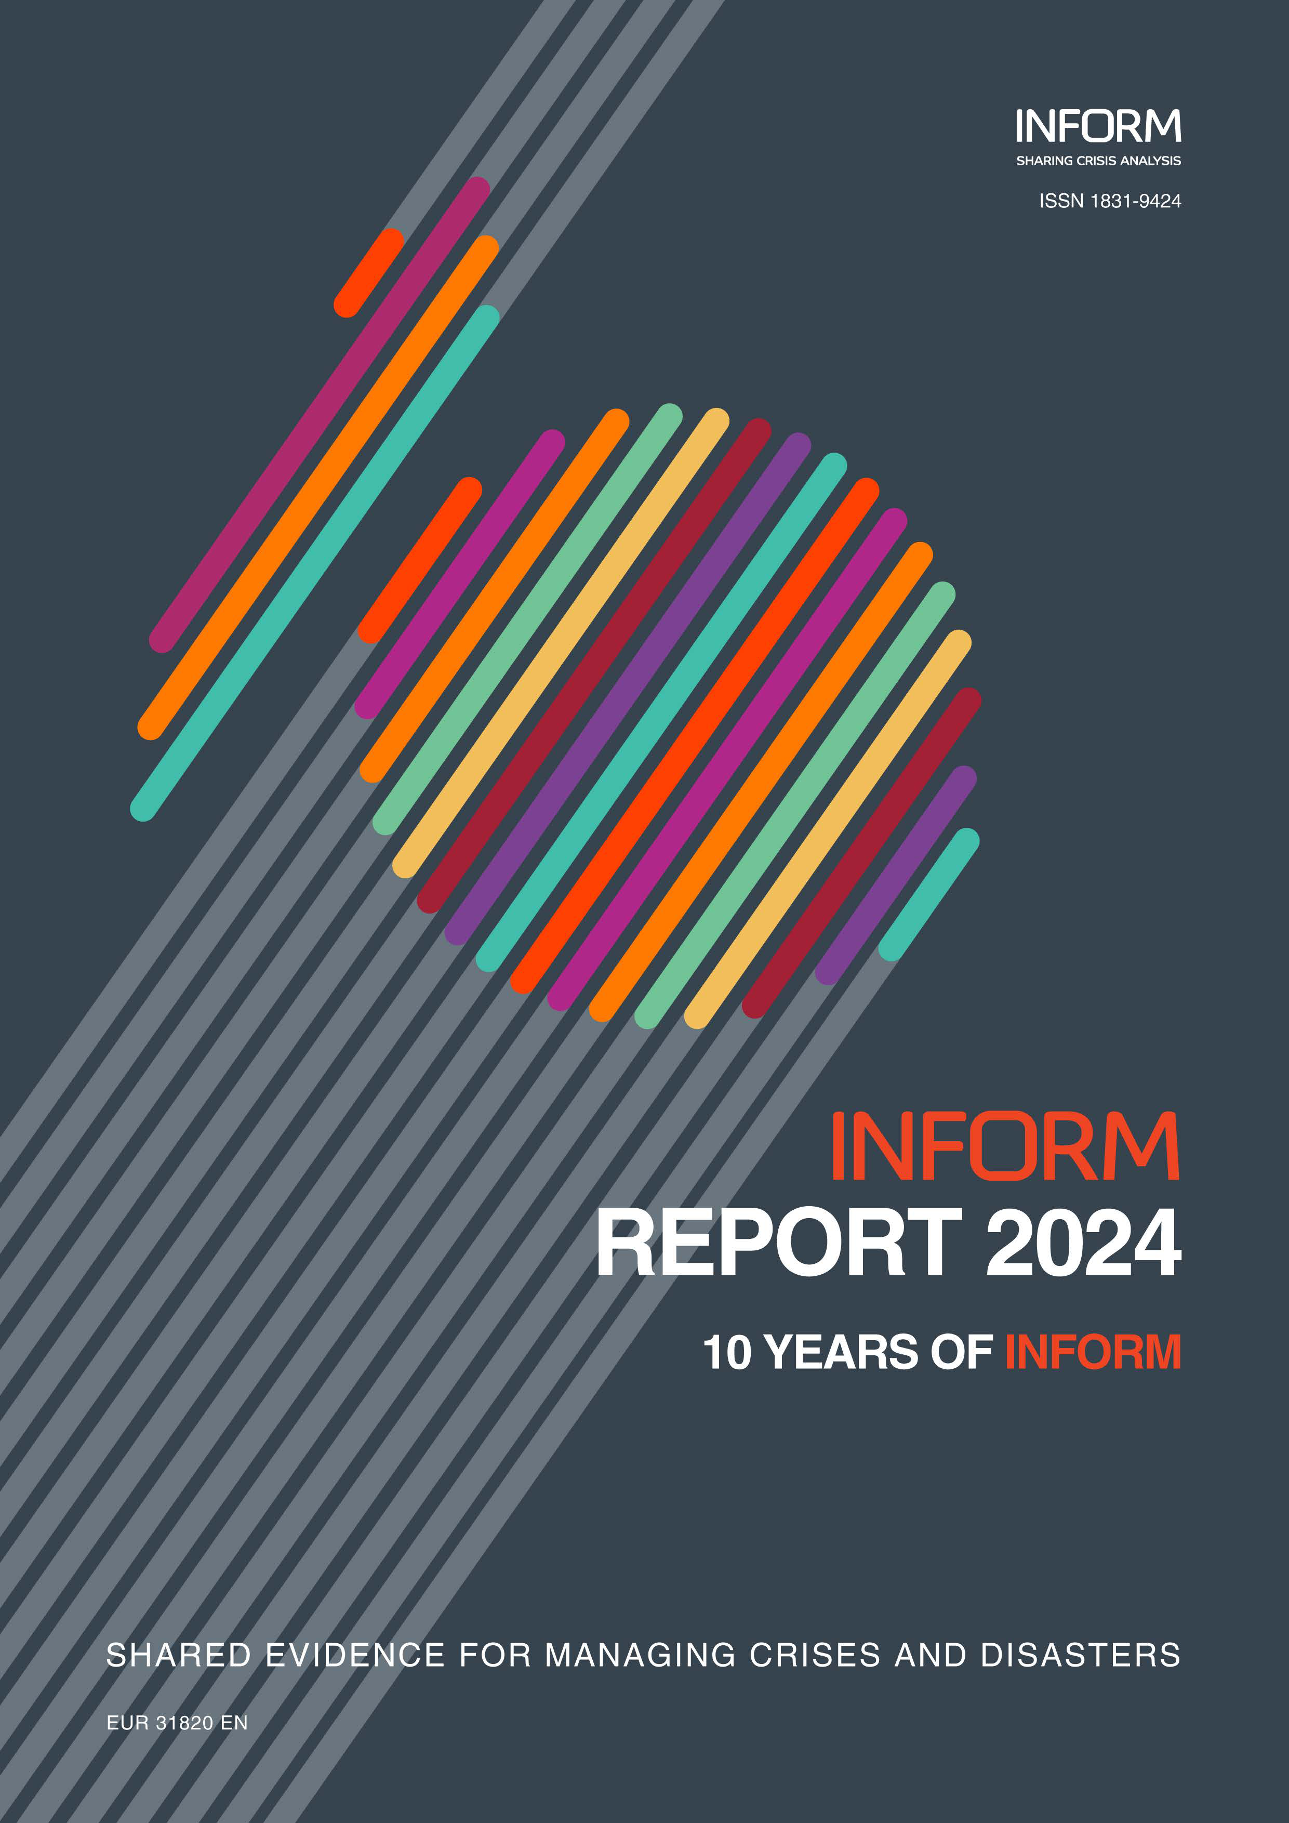

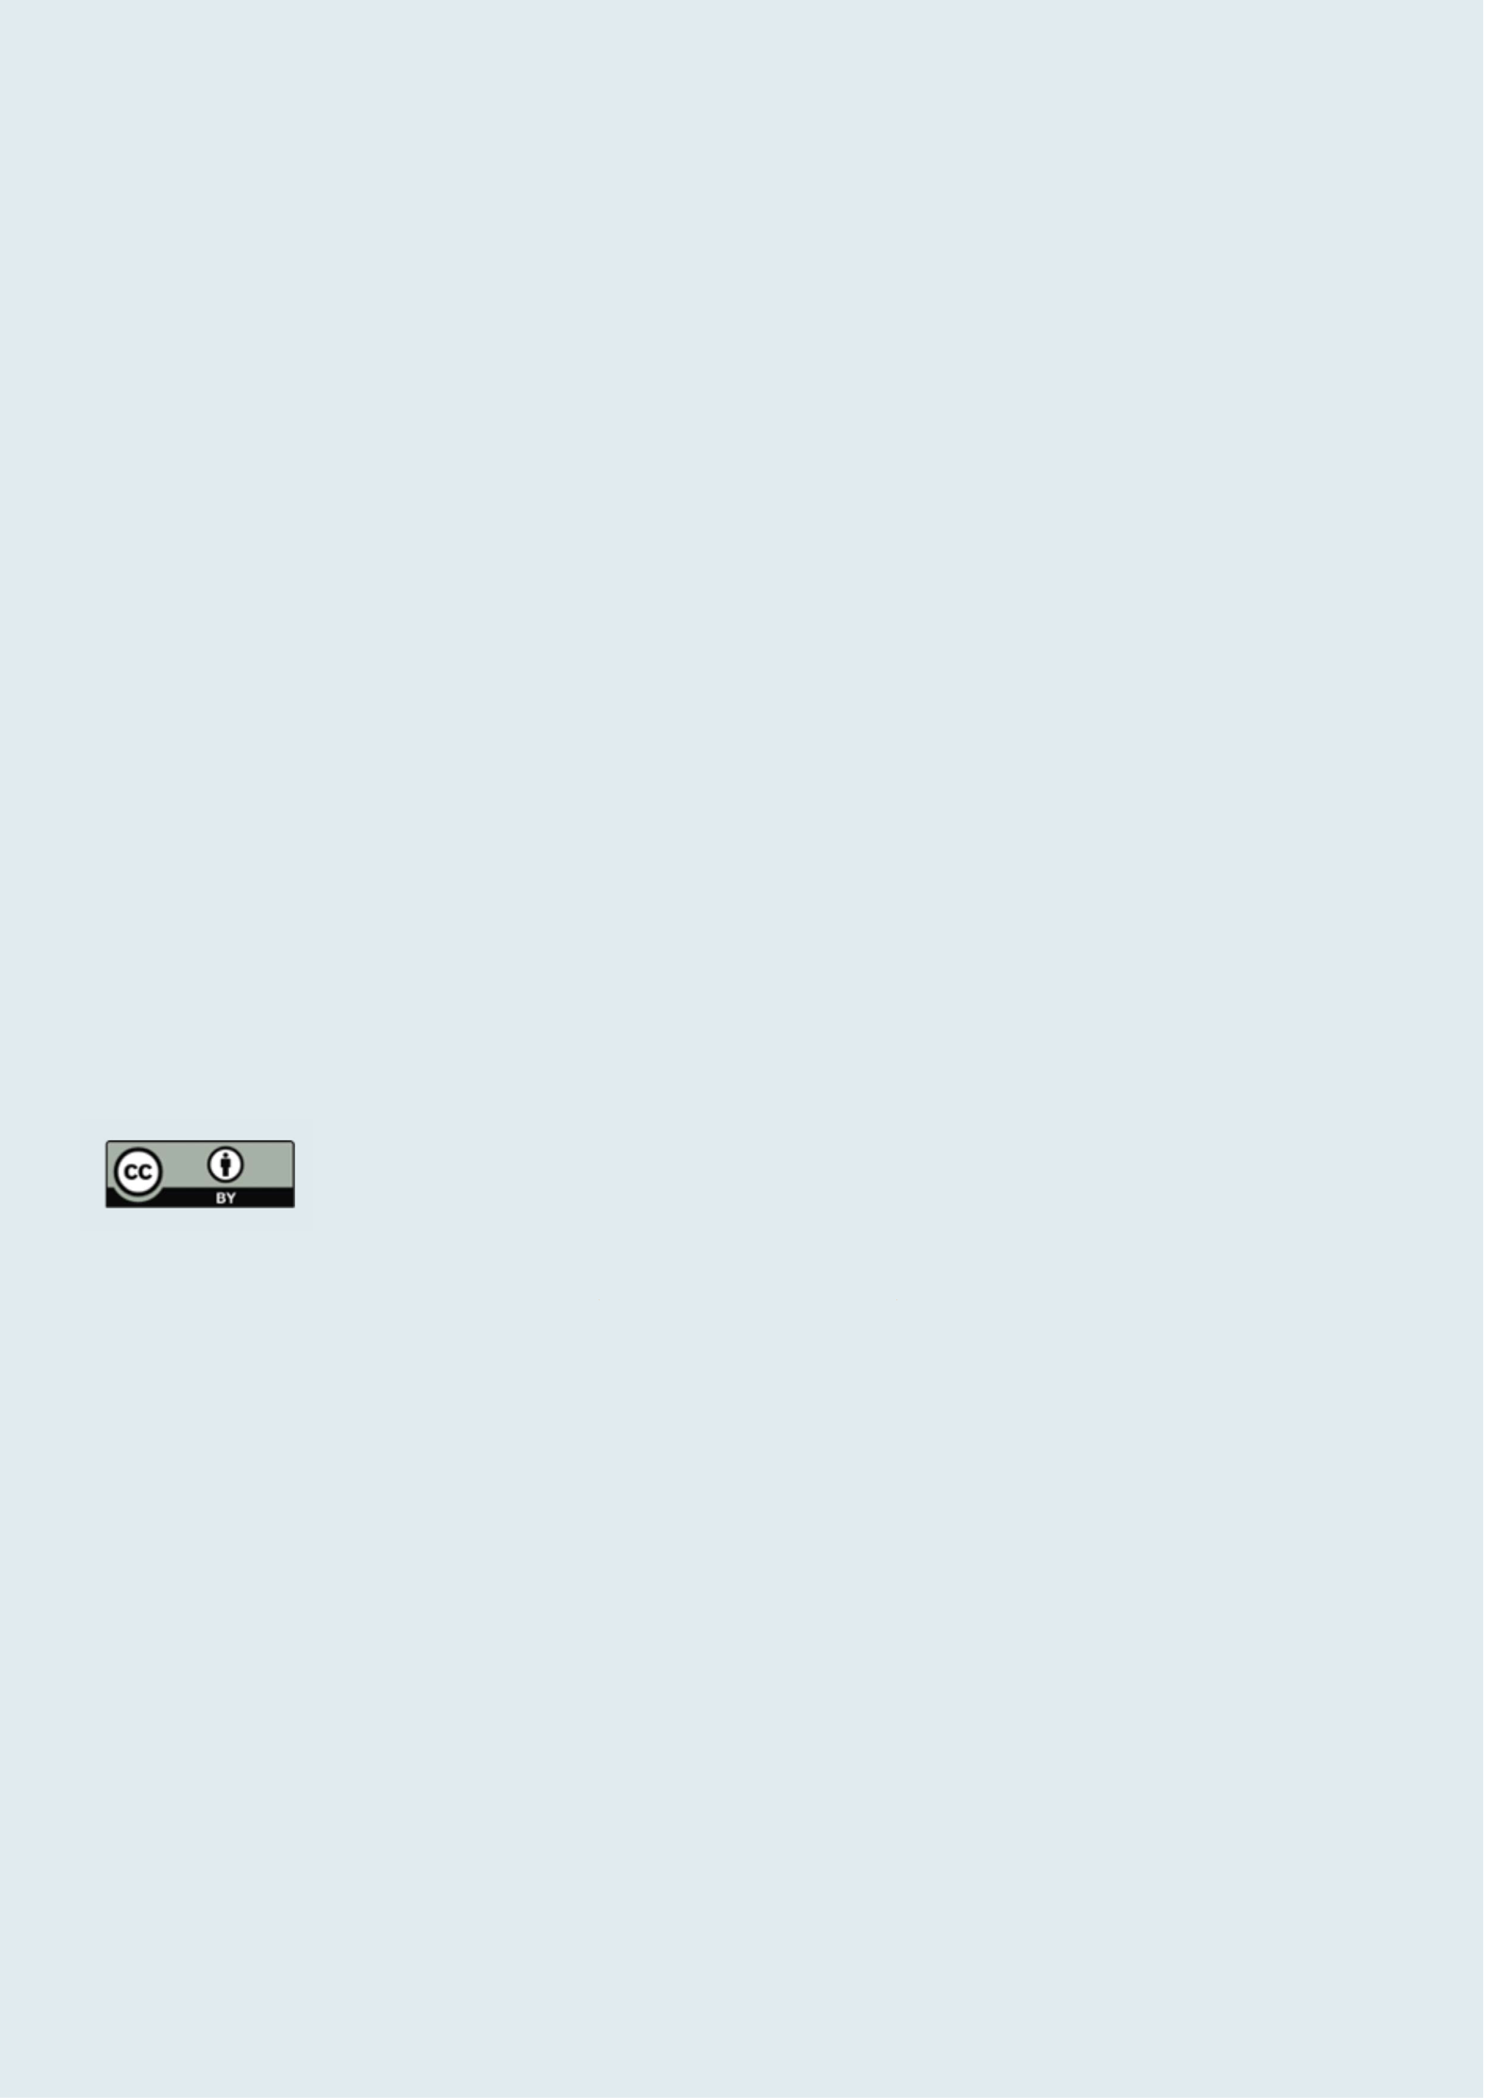

Shared analysis for better decisions   
10 years of INFORM

Note: The geographical boundaries and names shown and the designations used in this report are not warranted to be error free nor do they necessarily imply official endorsement or acceptance by INFORM or any INFORM partner organisation. Every effort has been made to ensure the accuracy of the information contained in this report. All information was believed to be correct as of May 2023.

INFORM is a collaboration of the Inter-Agency Standing Committee and the European Commission. This report is produced by the United Nations Office for the Coordination of Humanitarian Affairs on behalf of all INFORM Partners. The Joint Research Centre of the European Commission is the scientific and technical lead of INFORM.

The European Commission support for the production of this publication does not constitute endorsement of the contents, which reflects the views only of the authors, and the Commission cannot be held responsible for any use which may be made of the information contained therein.

For more information see **https://drmkc.jrc.ec.europa.eu/inform-index**

JRC 136641   
EUR 31820 EN

Print ISBN 978-92-68-13140-4 ISSN 1018-5593 doi:10.2760/817042 KJ-NA-31-820-EN-C PDF ISBN 978-92-68-11775-0 ISSN 1831-9424 doi:10.2760/555548 KJ-NA-31-820-EN-N

Luxembourg: Publications Office of the European Union, 2024   
© European Union, 2024

The reuse policy of the European Commission is implemented by the Commission Decision 2011/833/EU of 12 December 2011 on the reuse of Commission documents (OJ L 330, 14.12.2011, p. 39). Except otherwise noted,

Welcome to the INFORM 2024 report.

2024 marks the 10th year of release of the INFORM Risk Index. In 2014,

INFORM Partners first came together to create an open index for measuring

the risk of humanitarian crises globally. Since then, the INFORM Risk Index

and other INFORM products have become established and relied upon in

the decision-making systems of organisations across the multilateral system.

INFORM partners believe that the availability of shared analysis of crises and disasters can lead to better coordination of actors and better outcomes for at-risk and affected people. Specifically, INFORM creates a space and process for shared analysis that can support joint strategy development, planning and action to prevent, prepare for, respond to and recover from crises. This can bring together development, humanitarian and other actors

to manage risk and respond better when crises do occur.

This report looks back on how INFORM has developed over that last decade and analyses some trends in crises and crisis risk over that time. It sets out INFORM’s vision for a suite of products to support decision-making that are easy to use and open to everyone. This vision involves bringing scientific rigour to the process of analysing crises and pooling expertise to develop shared methodologies. By working together, we can reduce the investments required by individual organisations, assure the quality of our analysis and

make it available for the common good.

|  |  |
| --- | --- |
| the reuse of this document is authorised under the Creative Commons Attribution 4.0 International (CC BY 4.0) |  |

licence (https://creativecommons.org/licenses/by/4.0/). This means that reuse is allowed provided appropriate   
credit is given and any changes are indicated. For any use or reproduction of photos or other material that is not   
owned by the EU, permission must be sought directly from the copyright holders.

All content © European Union, 2024 (unless otherwise specified)

**How to cite this report**   
Inter-Agency Standing Committee and the European Commission, INFORM REPORT 2024: 10 years of INFORM,   
Publications Office of the European Union, Luxembourg, 2024, https://data.europa.eu/doi/10.2760/555548,   
JRC136641.

**How to obtain EU publications**   
You can view or order EU publications at **[op.europa.eu/en/publications](http://op.europa.eu/en/publications)**. Multiple copies of free publications   
can be obtained by contacting Europe Direct or your local documentation centre (**[european-union.europa.eu/](http://european-union.europa.eu/contact-eu/meet-us_en)**   
**[contact-eu/meet-us_en](http://european-union.europa.eu/contact-eu/meet-us_en)**).

1 2



Foreword

In a world increasingly marred by complex crises, the mix of conflict, climate issues and economic   
instability has exacerbated the reliance on humanitarian aid. Millions of people are displaced for long   
periods and food insecurity is rising. Humanitarian responses, despite heroic efforts to scale up,   
are struggling to meet people's needs, leaving more and more individuals without essential services   
during crises.

The European Union, grounded in the principle of solidarity, stands as the leading provider of   
humanitarian and development aid in the world by far. In the face of escalating crises, the EU’s   
commitment to providing humanitarian assistance remains firm. At the same time fostering   
development investment to address root causes of humanitarian crises is crucial for steering affected   
populations towards recovery and sustainable growth. And to do this correctly, we need scientific

evidence.

This is why, the INFORM Partners, including the European Commission and humanitarian and   
development organisations worldwide, joined forces ten years ago and created an open index for   
measuring the risk of humanitarian crises. Since then, the INFORM Risk Index and other INFORM   
products have become a key component of the decision-making systems of many organisations at   
global as well as local levels.

The uniqueness of INFORM lies in its ability to enrich existing knowledge and improve common   
understanding of disaster risks, the severity of the humanitarian crises and the impacts of climate   
change. Through collective effort, it delivers scientifically sound, independent and objective analyses,   
ensuring transparency and accountability in the political context of humanitarian aid. This facilitates   
evidence-based allocation of humanitarian aid and at the same time enables integrated strategies for   
disaster risk and crisis management.

The Commission, through its Joint Research Centre and the Department of Civil Protection and   
Humanitarian Aid Operations, exemplifies the effectiveness of integrating evidence-based knowledge   
into humanitarian actions. This alignment underscores the key role of science in bridging the   
humanitarian gap and transforming crisis management trends.

As we mark the 10th year anniversary of the INFORM Risk Index, the first analytical tool within the   
INFORM suite, we are reminded of the critical role of evidence-based collective action and the power   
of solidarity in addressing the challenges we face.

Looking ahead, let us leverage the scientific insights provided by INFORM to guide our humanitarian   
and development efforts, striving for a more resilient and sustainable future for all.

Together, we can make a difference and ensure that no one is left behind in times of crisis.

|  |  |  |  |
| --- | --- | --- | --- |
| 3 | Iliana Ivanova | Janez Lenar i | 4 |
| European Commissioner for Innovation, | European Commissioner for |
| Research, Culture, Education and Youth | Crisis Management |

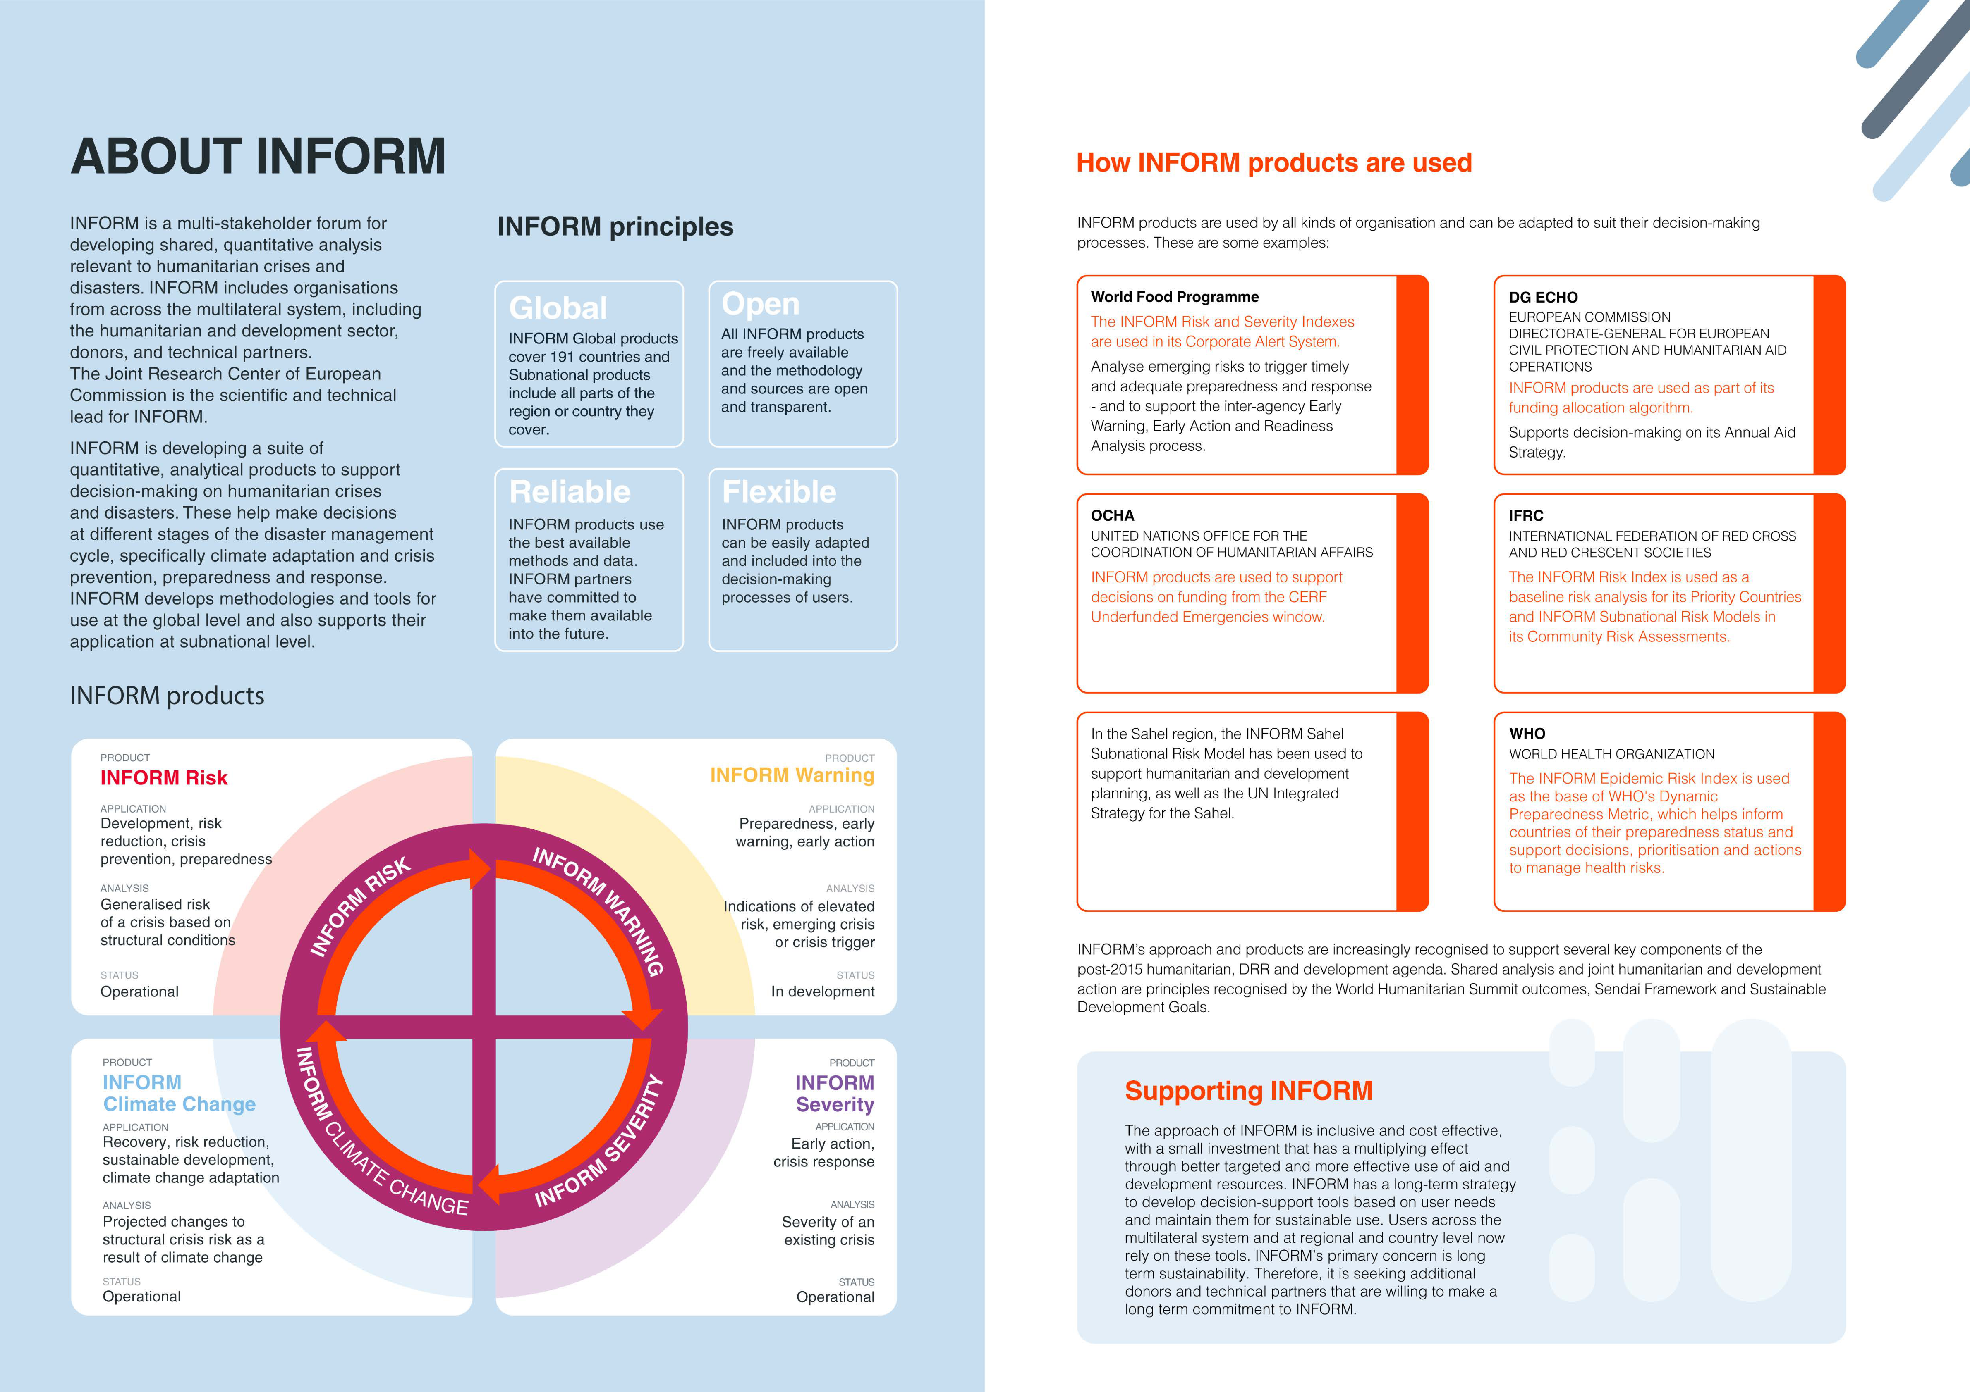

5 6

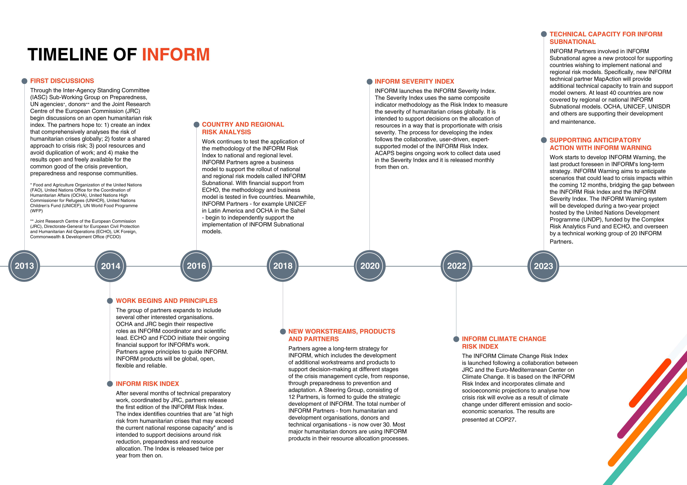

7 8

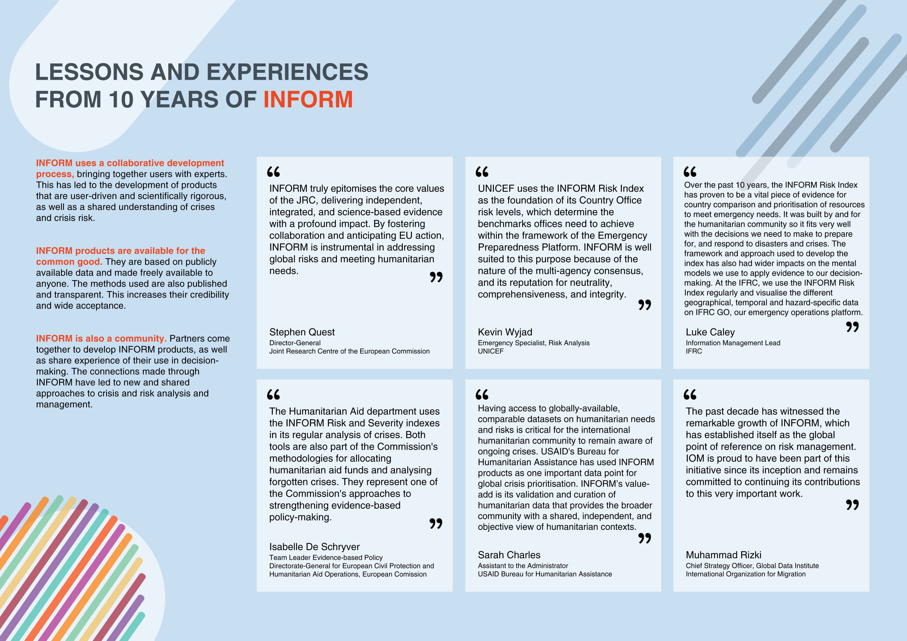

9 10





|  |  |  |  |  |  |  |  |  |  |  |  |  |  |  |  |  |  |  |  |  |  |  |  |  |  |  |  |  |  |  |  |  |
| --- | --- | --- | --- | --- | --- | --- | --- | --- | --- | --- | --- | --- | --- | --- | --- | --- | --- | --- | --- | --- | --- | --- | --- | --- | --- | --- | --- | --- | --- | --- | --- | --- |
| **INFORM SEVERITY INDEX** | | | | | | | | | | | | | | **ANALYTICAL FRAMEWORK** | | **RESULTS AND INTERPRETATION** | | | | | | | | | | | | | | | | |
| **AND METHODOLOGY** | | The results are provided by crisis. Each crisis | | | | | | | | | | | | | | | | |
| The INFORM Severity Index is a composite indicator that measures the severity of  humanitarian crises against a common scale.  The analytical framework describes how the Index is constructed. Indicators are collected to populate the analytical framework for every crisis and these indicators are used to calculate the Index.  The Index covers: • The impact of the crisis itself, in terms | | | | | is categorised on a five-level scale from very low to very high severity.  It is also possible to access the values for different levels of the analytical framework, to better understand the main drivers of a crisis. All the underlying data, metadata and methodology are publicly available.  The Index is updated every month and can be used for trend analysis. | | | | | | | | | | | | | |
| The INFORM Severity Index summarises a wide | **How it works** | | | | | | | | | | | | |
| range of already existing, quantitative information | | | | | | | | | | | | | |
| about crisis severity and presents it in a format that | 6.3 | | | | 5.7 | | 3.6 | | 2.1 | 5.5 | | 8.0 | 3.0 |
| can be used more easily in decision-making. |
| It aggregates information from a range of credible, | Crisis level | 7.5 | 6.8 | 8.0 | | | | | | | 10.0 | | |
| 6.2 | | | | | | | of the scope and of its geographical, human  and physical effects; | | | | | | | | | | | | | | | | | | |
| publicly available sources, such as UN agencies, | 4.7 |
| 2.5 | | | | | | |
| governments and other multilateral organisations. |
| data | 4.3 | • The conditions and status of the people | | | | | | INFORM Severity | | | | | | Index | INFORM Severity | Index Category | | | INFORM Severity | Index Category |
| Human analysts collect the data and enter it into the | 3.6 |
| affected, including information about the | | | | | |
| Index. |
| distribution of severity (i.e. the number of people | | | | | |
| 2.1 |
| in each category of severity within a crisis); | | | | | |
| It is intended to lead to a shared and objective  understanding of crisis severity that can support decisions on the allocation of resources and ensure all people affected by crises receive appropriate assistance. | 7.5  4.7 | | | | | | | | | | | | |
| 4.5 | | | | | | 3.4 | | | | | | | • The complexity of the crisis, in terms of factors | | | | | |
| 1.0 | | | | 4.7 | 5.5 | | | | | | | | that affect its mitigation or resolution. | | | | | |
| 7.5 | | | 2.1 | | | 7.5 | 4.5 | | | | | | INFORM Severity Index | | | Complex crisis | | | | | | 4.5 | | | | 5 | | Very High | | | |
| in Afghanistan | | | | | |
| Dimensions | | | | | | | | | | | | | | | | | | |
| Impact | Conditions | Complexity | | Mutliple crises in Bangladesh 2.7 | | | | | | | | | 3 | | Medium | | | |
| **Objectives**   |  |  | | --- | --- | | The overall objective of the INFORM Severity Index is | Human analyst |   to measure the severity of humanitarian crises globally  (i.e. between rather than within crises) and on an  ongoing, up-to-date and regular basis. It seeks to | | | | | | | | | | | | | | Rohingya refugee crisis | | | | | | 2.7 | | | 3 | | Medium | | | |
| of people |
| of the crisis | of the crisis | |
| affected | Cyclone Amphan Bangladesh 2.2 | | | | | | | | | 3 | | Medium | | | |
| Categories | | Rohingya Regional Crisis | | | | | | | | | 3.3 | | 4 | | | High | | |
| Conflict in Burkina Faso | | | | | | | | | | 3.5 | | | 4 | | | High | | |
| communicate the current status of crises in a systematic, objective and understandable way. | Impact of the crisis | | | | | | | | | | | | | Complex crisis in Afghanistan | | | | | | | | | | | | | | | | | | |
| In its use - in combination with other sources of | Analytical | | Conditions | | | | | | | | | | |
| information - the INFORM Severity Index is intended to: | INFORM Severity Index | | | | | | | | | | | | | 4 .5 | | | | | |
| framework | | of people affected | | | | | | | | | | |
| Components | | INFORM Severity Index Category | | | | | | | | | | | 5 | | | | | |
| Extreme | | INFORM Severity Index Category | | | | | | | | | | | Very High | | | | | |
| Lead to a shared and objective | Complexity of the crisis | | | | | | | | | | | | | Impact of the crisis | | | | | | | | | | | 4.9 | | | | | |
| conditions | |
| understanding of crisis severity  Contribute to decisions on the | | | | | | | | | | | | | | Geographical | | | | | | | | | | | | | 4.8 | | | | | |
| Severe | | Human | | | | | | | | | | | 5.0 | | | | | |
| conditions | |
| Conditions of affected people | | | | | | | | | | | | | 4.5 | | | | | |
| Moderate | | People in need | | | | | | | | | | | 5.0 | | | | | |
| conditions | |
| Conditions of people affected | | | | | | | | | | | | | 4.0 | | | | | |
| allocation of resources in a way that is proportionate with crisis severity | Composite  indicator methodology | | | | | | | | | | | | |
| Stressed | | Complexity of the crisis | | | | | | | | | | | 4.2 | | | | | |
| conditions | |
| Justify and advocate for action, | CRISIS 1 | | | | | | Very high | | | | | | | Society and safety | | | | | | | | | | | 3.9 | | | | | |
| None/minimal | | Operating environment | | | | | | | | | | | 4.5 | | | | | |
| conditions | |
| especially in the case of forgotten | INFORM | CRISIS 2 | | | | | Very high | | | | | | |
| or unrecognised crises. |
| Severity | CRISIS 3 | | | | | High | | | | | | | **Using the Severity Index** | | | | | | | | | | | | | | | | | | |
| Index |
| The INFORM Severity Index can be | | It should not be used for decisions | | | | | The INFORM Severity Index is only | | | | | | | | | | | |
| CRISIS 4 | | | | | | | High | | | | | | |
| used to support decisions that require | | about the operational response to a | | | | | | one source of information that can | | | | | | | | | | |
| Monitor trends in crisis severity | CRISIS 5 | | | | | | Medium | | | | | | |
| an understanding of the severity of | | specific crisis. Crisis-specific | | | | support decisions about humanitarian | | | | | | | | | | | | |
| over time. |
| crises globally or to understand | | information like needs assessments | | | | | | crises. It should typically be | | | | | | | | | | |
| CRISIS 6 | | | | | | | Medium | | | | | | |
| changes in crisis severity over time. | | and appeals should be used | | | | complemented by risk, early warning | | | | | | | | | | | | |
| CRISIS 7 | | | | | | | Low | | | | | | |
| to support these decisions. | | | | | | and capacity information. | | | | | | | | | | | | |
| 13 | | | | | | | | | | | | | | 14 | | | | | | | | | | | | | | | | | | |

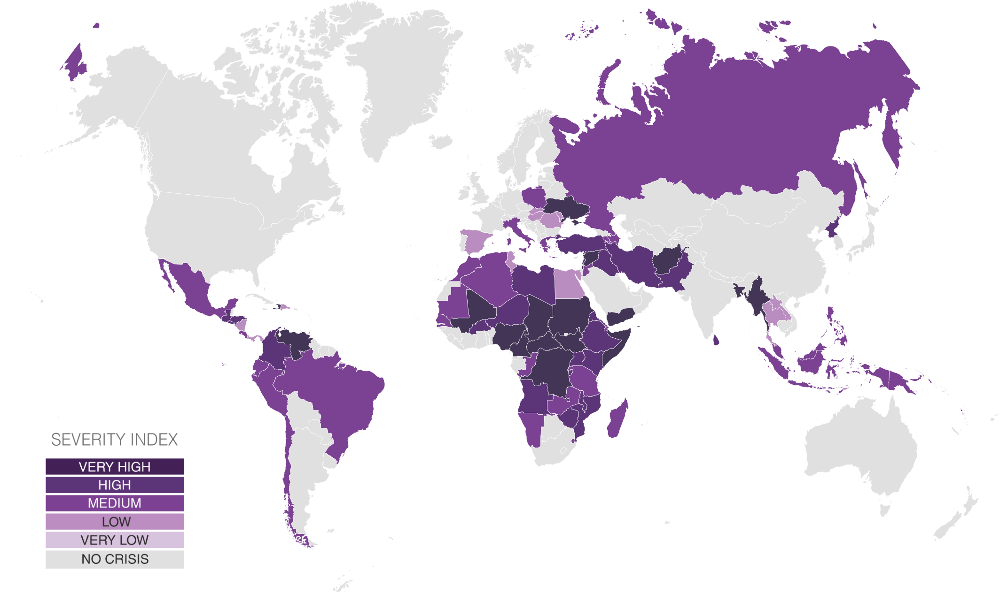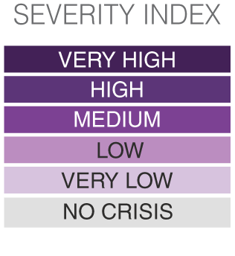

INFORM SEVERITY INDEX RESULTS   
Country level, October 2023

|  |  |  |  |  |
| --- | --- | --- | --- | --- |
| COUNTRY | CRISIS | SEVERITY  (Country level) | INFORM Severity category | 3 MONTH TREND |
| Afghanistan | Complex crisis in Afghanistan | 4.4 | Very High | Stable |
| Algeria | Multiple crises in Algeria | 2.6 | Medium | Stable |
| Angola | Drought in South-West Angola | 3.1 | High | Stable |
| Armenia | Nagorno-Karabakh Conflict in Armenia | 2.1 | Medium | Increasing |
| Azerbaijan | Nagorno-Karabakh conflict in Azerbaijan | 2.1 | Medium | Increasing |
| Bangladesh | Complex crisis in Bangladesh | 4.1 | Very High | - |
| Brazil | Country level Brazil | 2.6 | Medium | Decreasing |
| Burkina Faso | Conflict in Burkina Faso | 4.0 | High | Increasing |
| Burundi | Complex in Burundi | 3.3 | High | Decreasing |
| Cameroon | Multiple crises in Cameroon | 4.1 | Very High | Increasing |
| CAR | Complex crisis in CAR | 4.2 | Very High | Stable |
| Chad | Complex crisis in Chad | 4.3 | Very High | Decreasing |
| Chile | Venezuela displacement in Chile | 2.5 | Medium | Increasing |
| Colombia | Complex crisis in Colombia | 3.9 | High | Decreasing |
| Congo | Complex crisis in Congo | 2.2 | Medium | Stable |
| Costa Rica | Nicaraguan refugees in Costa Rica | 2.1 | Medium | Stable |
| Djibouti | Multiple crises in Djibouti | 2.9 | Medium | Increasing |
| Dominican Republic | Venezuela displacement in Dominican Republic | 1.8 | Low | Decreasing |
| DPRK | Complex crisis in DPRK | 3.7 | High | Stable |
| DRC | Complex crisis in DRC | 4.4 | Very High | Decreasing |
| Ecuador | Venezuela displacement in Ecuador | 2.6 | Medium | Decreasing |
| Egypt | Refugee Crisis in Egypt | 2.0 | Low | Increasing |
| El Salvador | Complex crisis in El Salvador | 3.2 | High | Increasing |
| Eritrea | Complex crisis in Eritrea | 3.5 | High | Increasing |
| Eswatini | Food Security Crisis in Eswatini | 2.4 | Medium | Increasing |
| Ethiopia | Complex crisis in Ethiopia | 4.0 | High | Decreasing |
| Greece | Mixed migration flows in Greece | 2.1 | Medium | Increasing |
| Guatemala | Complex crisis in Guatemala | 3.5 | High | Increasing |
| Haiti | Complex crisis in Haiti | 4.2 | Very High | Stable |
| Honduras | Complex crisis in Honduras | 3.6 | High | Stable |
| Hungary | Displacement from Ukraine conflict in Hungary | 1.2 | Low | Decreasing |
| India | Conflict in Jammu and Kashmir | x | x | - |
| Indonesia | Papua Conflict | 2.5 | Medium | Decreasing |
| Iran | Afghan Refugees in Iran | 3.6 | High | Stable |
| Iraq | Multiple crises in Iraq | 3.8 | High | Decreasing |
| Italy | Mixed migration flows in Italy | 2.6 | Medium | Increasing |
| Jordan | Syrian refugees in Jordan | 3.0 | Medium | Increasing |
| Kenya | Multiple crisis in Kenya | 3.5 | High | Decreasing |
| Laos | 2023 Floods in Laos | 1.5 | Low | - |
| Lebanon | Socioeconomic crisis in Lebanon | 3.5 | High | Decreasing |
| Libya | Complex crisis in Libya | 3.8 | High | Increasing |
| Madagascar | Multiple crisis in Madagascar | 2.9 | Medium | Decreasing |
| Malawi | Complex crisis in Malawi | 3.4 | High | Decreasing |
| Malaysia | International Refugees in Malaysia | 2.3 | Medium | Decreasing |
| Mali | Complex crisis in Mali | 4.3 | Very High | Stable |
| Mauritania | Food Security in Mauritania | 2.6 | Medium | Decreasing |
| Mexico | Multiple crisis in Mexico | 2.8 | Medium | Stable |
| Moldova | Displacement from Ukraine conflict in Moldova | 1.6 | Low | Decreasing |
| Morocco | Mixed migration flows in Morocco | 2.9 | Medium | - |
| Mozambique | Multiple Crises in Mozambique | 3.5 | High | Stable |
| Myanmar | Multiple crises in Myanmar | 4.6 | Very High | Stable |
| Namibia | Food Security Crisis in Namibia | 2.3 | Medium | Increasing |

The depiction and use of boundaries are not warranted to be error free nor do they necessarily imply official endorsement or acceptance by the United Nations and European Union.

|  |  |  |  |  |  |  |  |  |  |  |
| --- | --- | --- | --- | --- | --- | --- | --- | --- | --- | --- |
| |  |  | | --- | --- | | COUNTRY | Very Low | | |  |  |  |  | | --- | --- | --- | --- | | CRISIS Low | Medium | High | V | | Very High (Country level) SEVERITY | INFORM  category Severity No crisis | severity 3 MONTH  TREND |
| Nicaragua | Socioeconomic crisis in Nicaragua | 1.9 | Low | - |
| Niger | Multiple crises in Niger | 3.8 | High | Stable |
| Nigeria | Complex crisis in Nigeria | 4.1 | Very High | Stable |
| Pakistan | Complex crisis in Pakistan | 3.9 | High | Stable |
| Palestine | Conflict in Palestine | 4.1 | Very High | Increasing |
| Panama | Venezuela displacement in Panama | 2.0 | Low | Decreasing |
| Papua New Guinea | Highlands Violence | 2.5 | Medium | Stable |
| Peru | Venezuela displacement in Peru | 2.9 | Medium | Decreasing |
| Philippines | Multiple crises in the Philippines | 2.5 | Medium | Increasing |
| Poland | Displacement from Ukraine conflict in Poland | 2.2 | Medium | Decreasing |
| Romania | Displacement from Ukraine conflict in Romania | 1.7 | Low | Increasing |
| Russia | Displacement from Ukraine conflict in Russia | 2.7 | Medium | - |
| Rwanda | Burundi and DRC refugees in Rwanda | 2.4 | Medium | Stable |
| Senegal | Drought in Senegal | 2.7 | Medium | Increasing |
| Slovakia | Displacement from Ukraine conflict in Slovakia | 1.6 | Low | Decreasing |
| Somalia | Complex crisis in Somalia | 4.7 | Very High | Stable |
| South Sudan | Complex crisis in South Sudan | 4.4 | Very High | Stable |
| Spain | Mixed migration flows in Spain | 1.9 | Low | Stable |
| Sri Lanka | Multiple crises in Sri Lanka | 3.3 | High | - |
| Sudan | Complex crisis in Sudan | 4.8 | Very High | Increasing |
| Syria | Syrian conflict | 4.6 | Very High | Stable |
| Tanzania | Multiple crises in Tanzania | 2.6 | Medium | Decreasing |
| Thailand | Multiple situations in Thailand | 1.8 | Low | Stable |
| Trinidad and Tobago | Venezuelan refugees in Trinidad and Tobago | 1.8 | Low | Decreasing |
| Tunisia | Mixed migration flows in Tunisia | 2.0 | Low | Increasing |
| Türkiye | Complex situation in Turkey | 3.5 | High | Stable |
| Uganda | International Displacement in Uganda | 3.2 | High | Stable |
| Ukraine | Conflict in Ukraine | 4.3 | Very High | Stable |
| Vanuatu | Cyclone Judy and cyclone Kevin in Vanuatu | 2.3 | Medium | Stable |
| Venezuela | Complex crisis in Venezuela | 4.3 | Very High | Increasing |
| Yemen | Conflict in Yemen | 4.7 | Very High | Stable |
| Zambia | Drought in Zambia | 3.0 | Medium | Stable |
| Zimbabwe | Complex crisis in Zimbabwe | 3.5 | High | Stable |

15 16

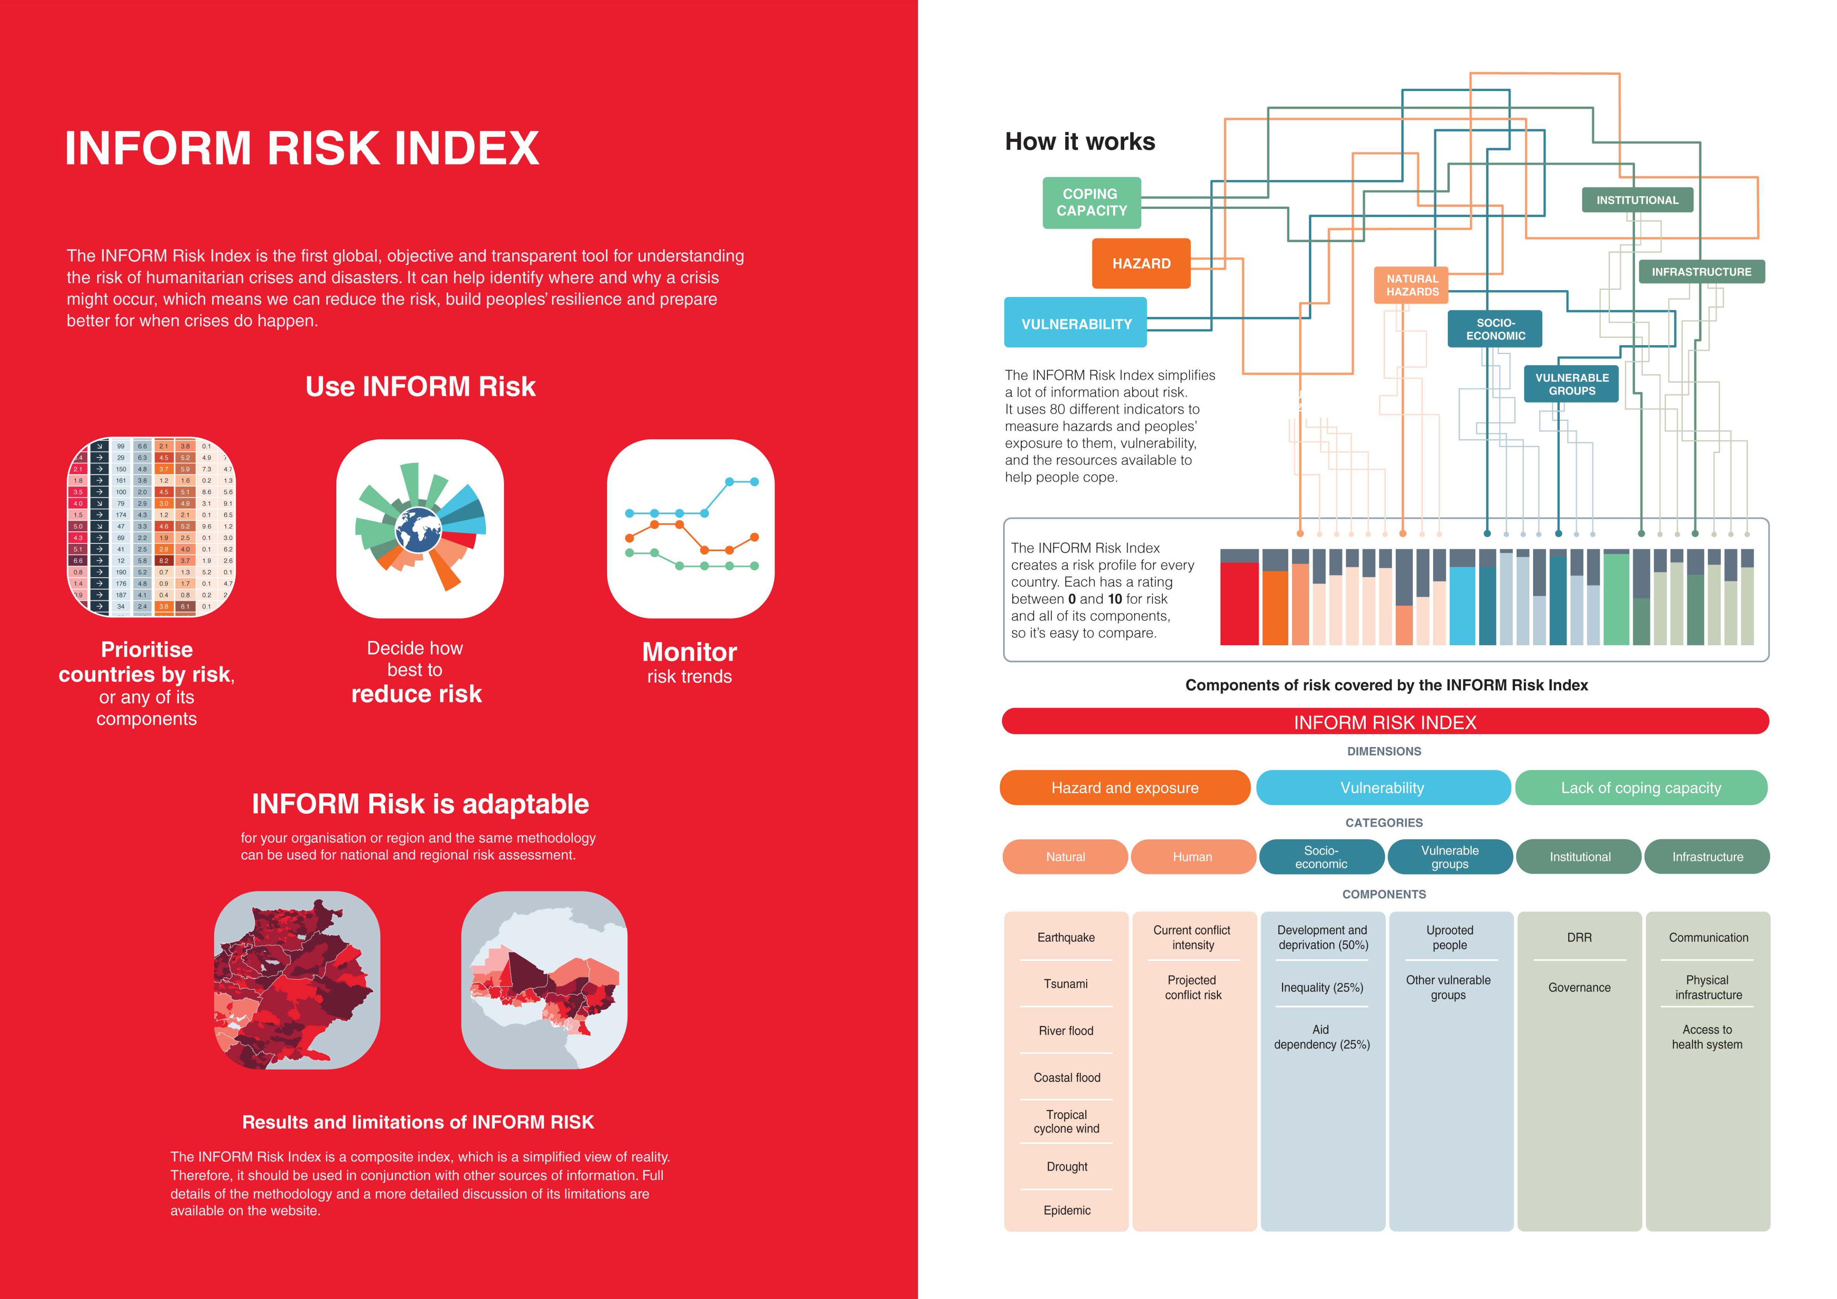

14 18

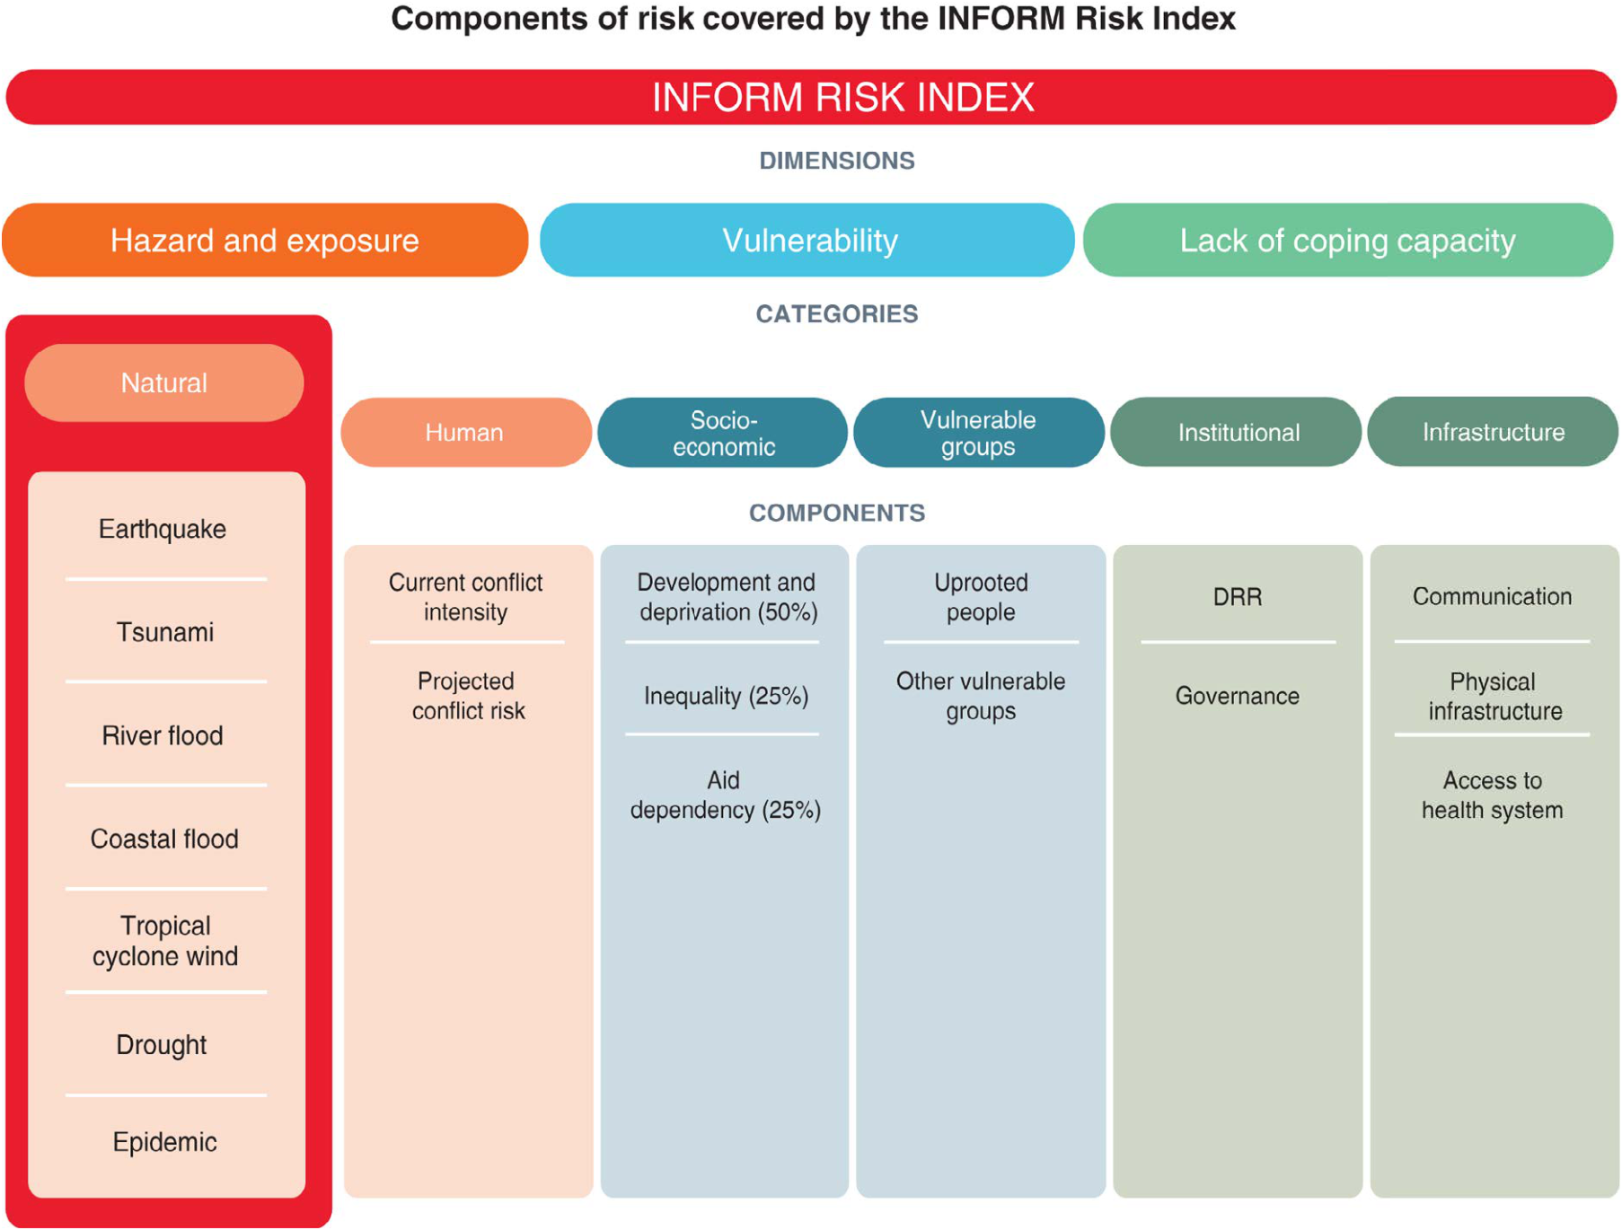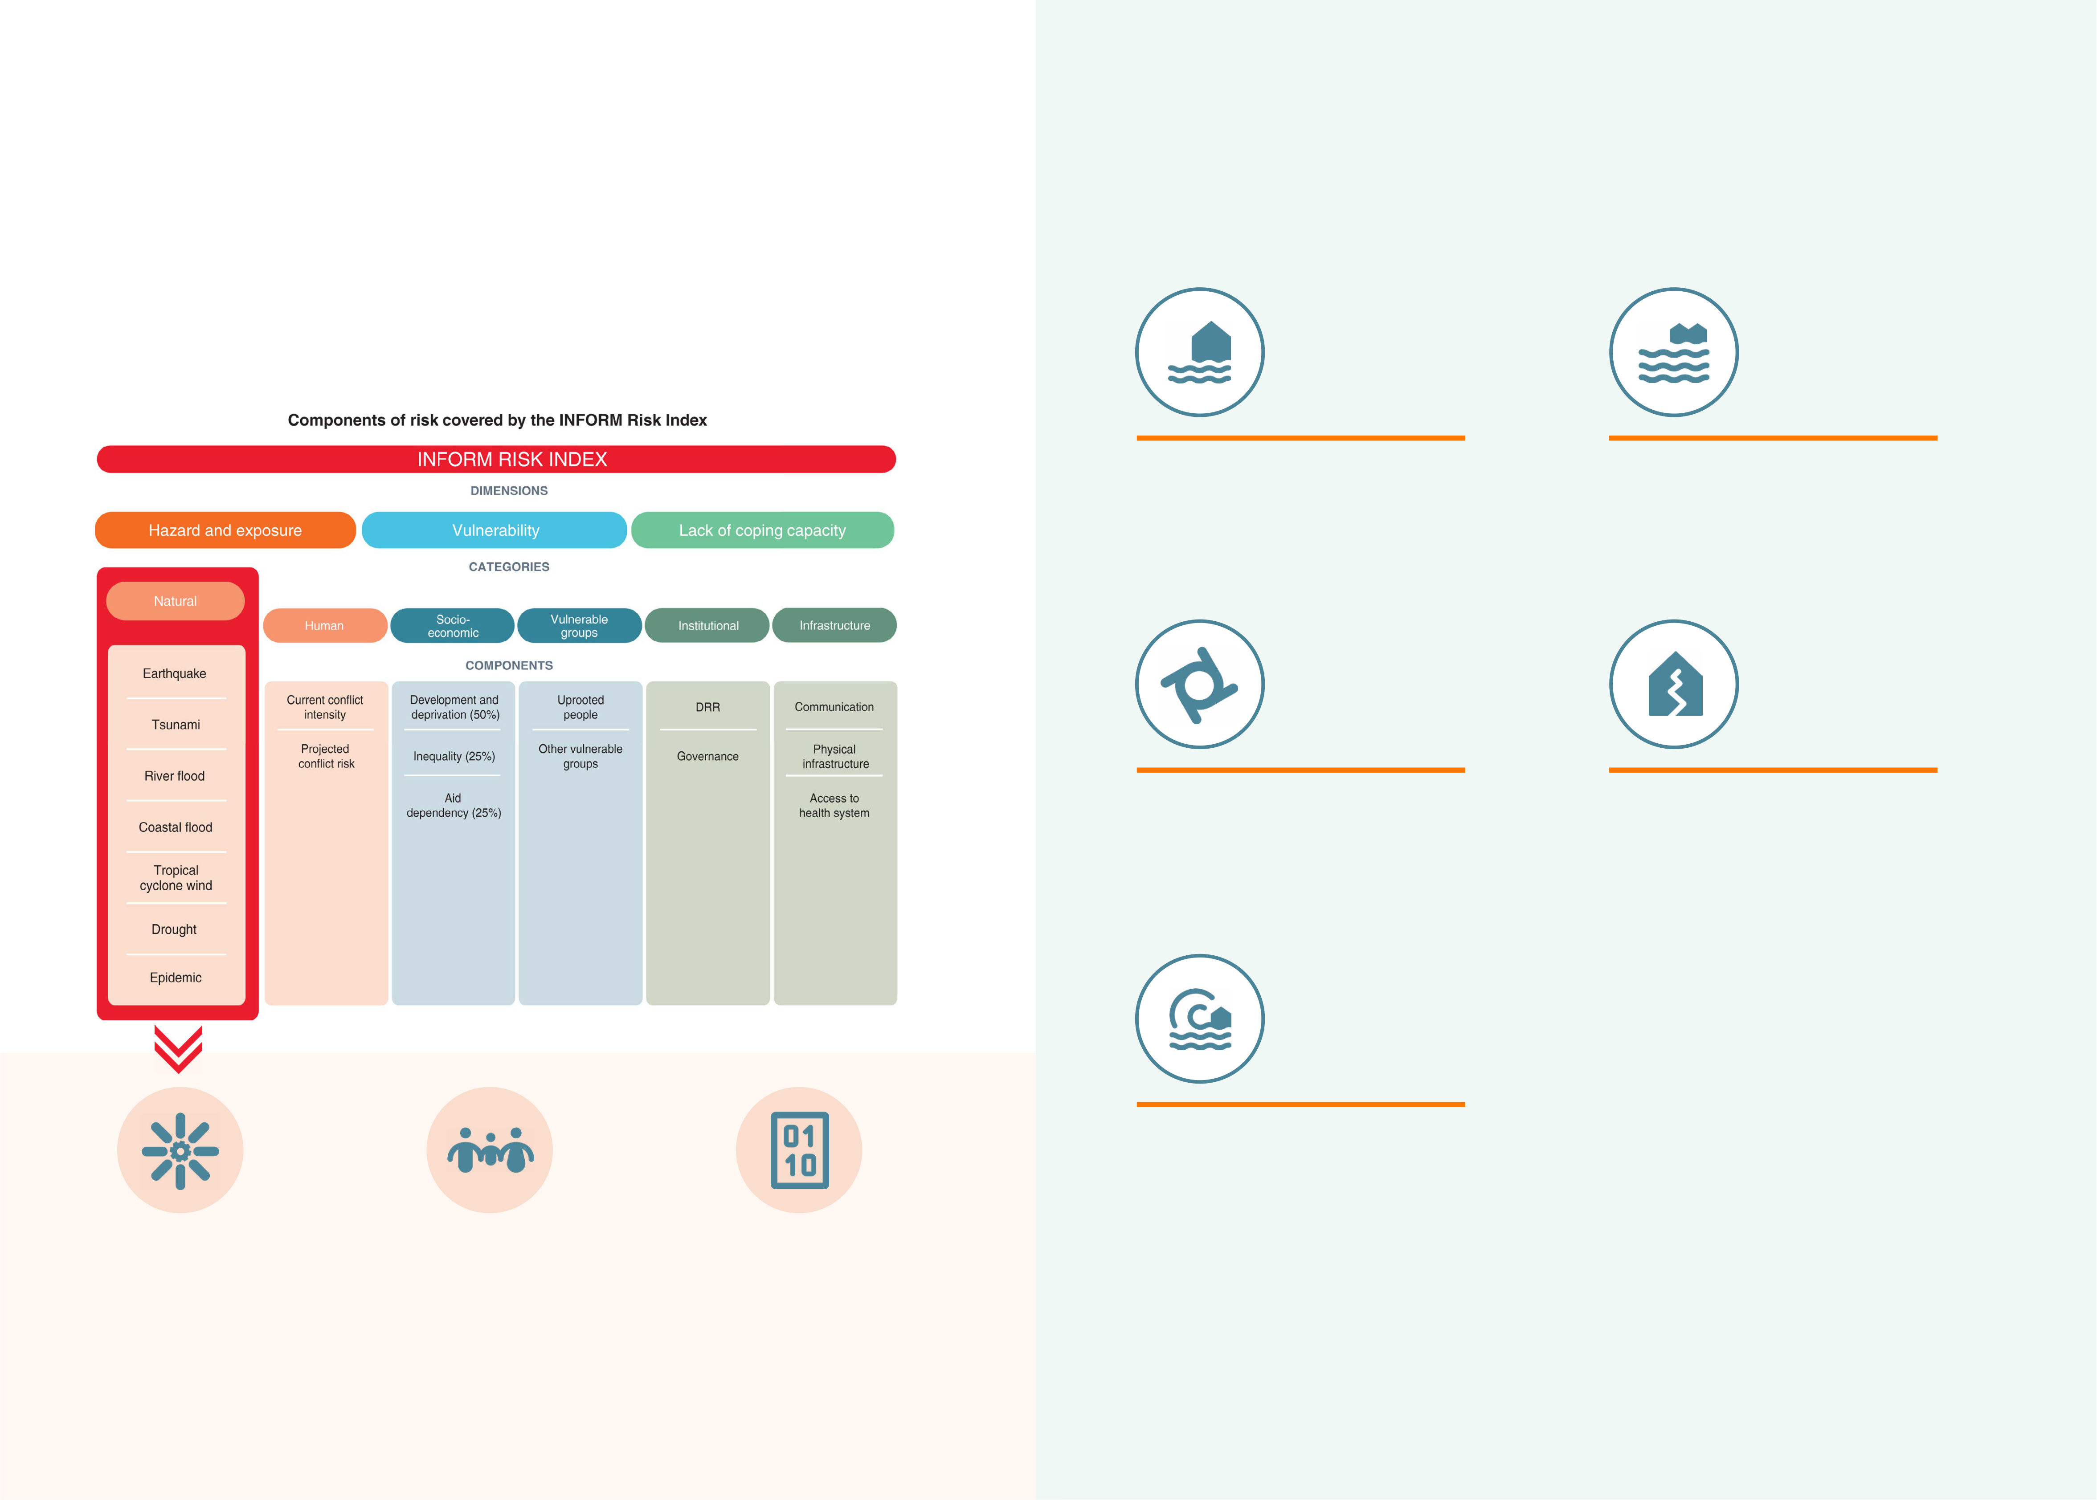

INFORM RISK 2024   
Natural Hazard updates

Data sources for the updated model of sudden-onset natural hazards

For the 2024 INFORM Risk Index, we introduce an updated methodology for calculating the Natural Hazard category of the

Hazards and Exposure dimension. The objectives of the update are to: 1) Introduce newly available, state-of-the-art models

|  |  |  |
| --- | --- | --- |
| of sudden-onset hazards and multi-temporal population distribution to improve the quality of the risk analysis of humanitarian | **RIVER** | **COASTAL** |
| crises and allow for better trend analysis; 2) Integrate new hazards and data that provide better information on hazards that |
| **FLOOD** | **FLOOD** |
| are exacerbated by climate change and align the INFORM Risk and INFORM Climate Change Risk Indexes. The update |

covers three main areas:

|  |  |
| --- | --- |
| JRC River flood hazard maps for several  return periods (10, 20, 50, 100, 200, 500)  developed at 1kmx1km resolution driven  by GloFAS data1.  **CYCLONE** | JRC probabilistic coastal flood  simulations of ESL for different return periods (5, 10, 20, 50,200, 500, and 1000-year events) from LISFLOOD-FP2.  **EARTHQUAKE** |

|  |  |
| --- | --- |
| Bloemendaal et al. (2022) TC STORM  globally consistent wind speed RP maps  at 10-km resolution and for various RPs  up to 1000 years3. | The Global Earthquake Model (GEM) Global Seismic Hazard Map (version 2018.1) depicts the geographic  distribution of the Peak Ground  Acceleration (PGA) with a 10%  probability of being exceeded in 50 years, computed for reference rock conditions (shear wave velocity, V, of 760-800 m/s)4. |

**TSUNAMI**

UNISDR GAR 2015 tsunami hazard map   
for 500-year return period developed at   
a grid resolution of 100m5.

|  |  |  |  |  |  |
| --- | --- | --- | --- | --- | --- |
| 19 | **Conceptual framework** | **Population dynamics** | **New data sources** | 1 <https://data.jrc.ec.europa.eu/collection/id-0054> | 20 |
| Introducing the new Global | Introducing new data sources |
| **and indicators** |
| Dividing the flood hazard | Human Settlement Layer (GHSL) | for specific hazards (except | 2 <https://data.jrc.ec.europa.eu/dataset/9e5ba6f1-8d03-4834-8488-2353e504560f> |
| to improve the calculation of | Tsunami) to take account | <https://doi.org/10.1038/s41467-018-04692-w>; <https://doi.org/10.1038/s41558-018-0260-4> |
| component into separate |
| exposure to natural hazards and | of recent improvements. | 3 Bloemendaal et al., Sci. Adv. 8, eabm8438 (2022), <https://doi.org/ 10.1126/sciadv.abm8438> |
| coastal flood and river flood |
| trends over time. The GHSL is a | Replacing GAR 2015 layers | 4 <https://www.globalquakemodel.org/gem> |
| and aligning the INFORM Risk |
| global multi-temporal (1975-2030, | with state-of-the-art hazard | 5 UNISDR Global Assessment Report 2015 - GAR15, Tsunami methodology and result overview. NGI report 20120052-03-R |
| Index and INFORM Climate |
| 5-year interval) layer depicting | maps. | For further information see: Poljansek, K.,Marzi, S., Essenfelder, A.H., Dalla Valle, D., Ronco, M., Voukouvalas, E., Corbane, C., 2024. INFORM |
| Change Risk Index. |
| the distribution of population. | Risk Index: Concept and Methodology, Version 2024, Publications Office of the European Union, Luxembourg (in preparation) |

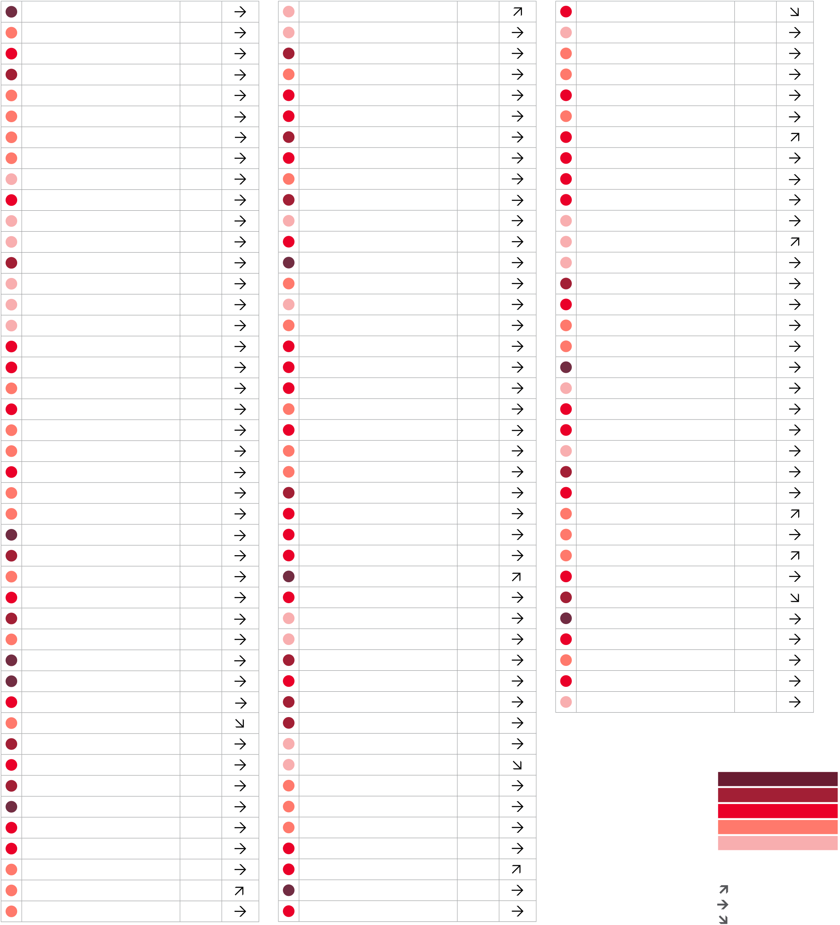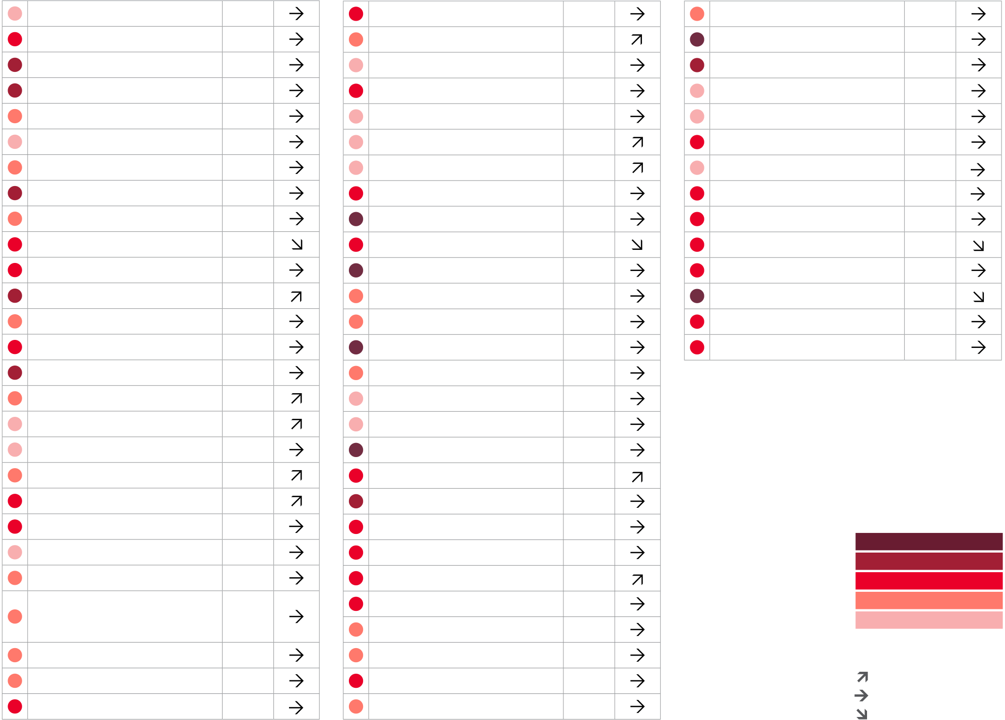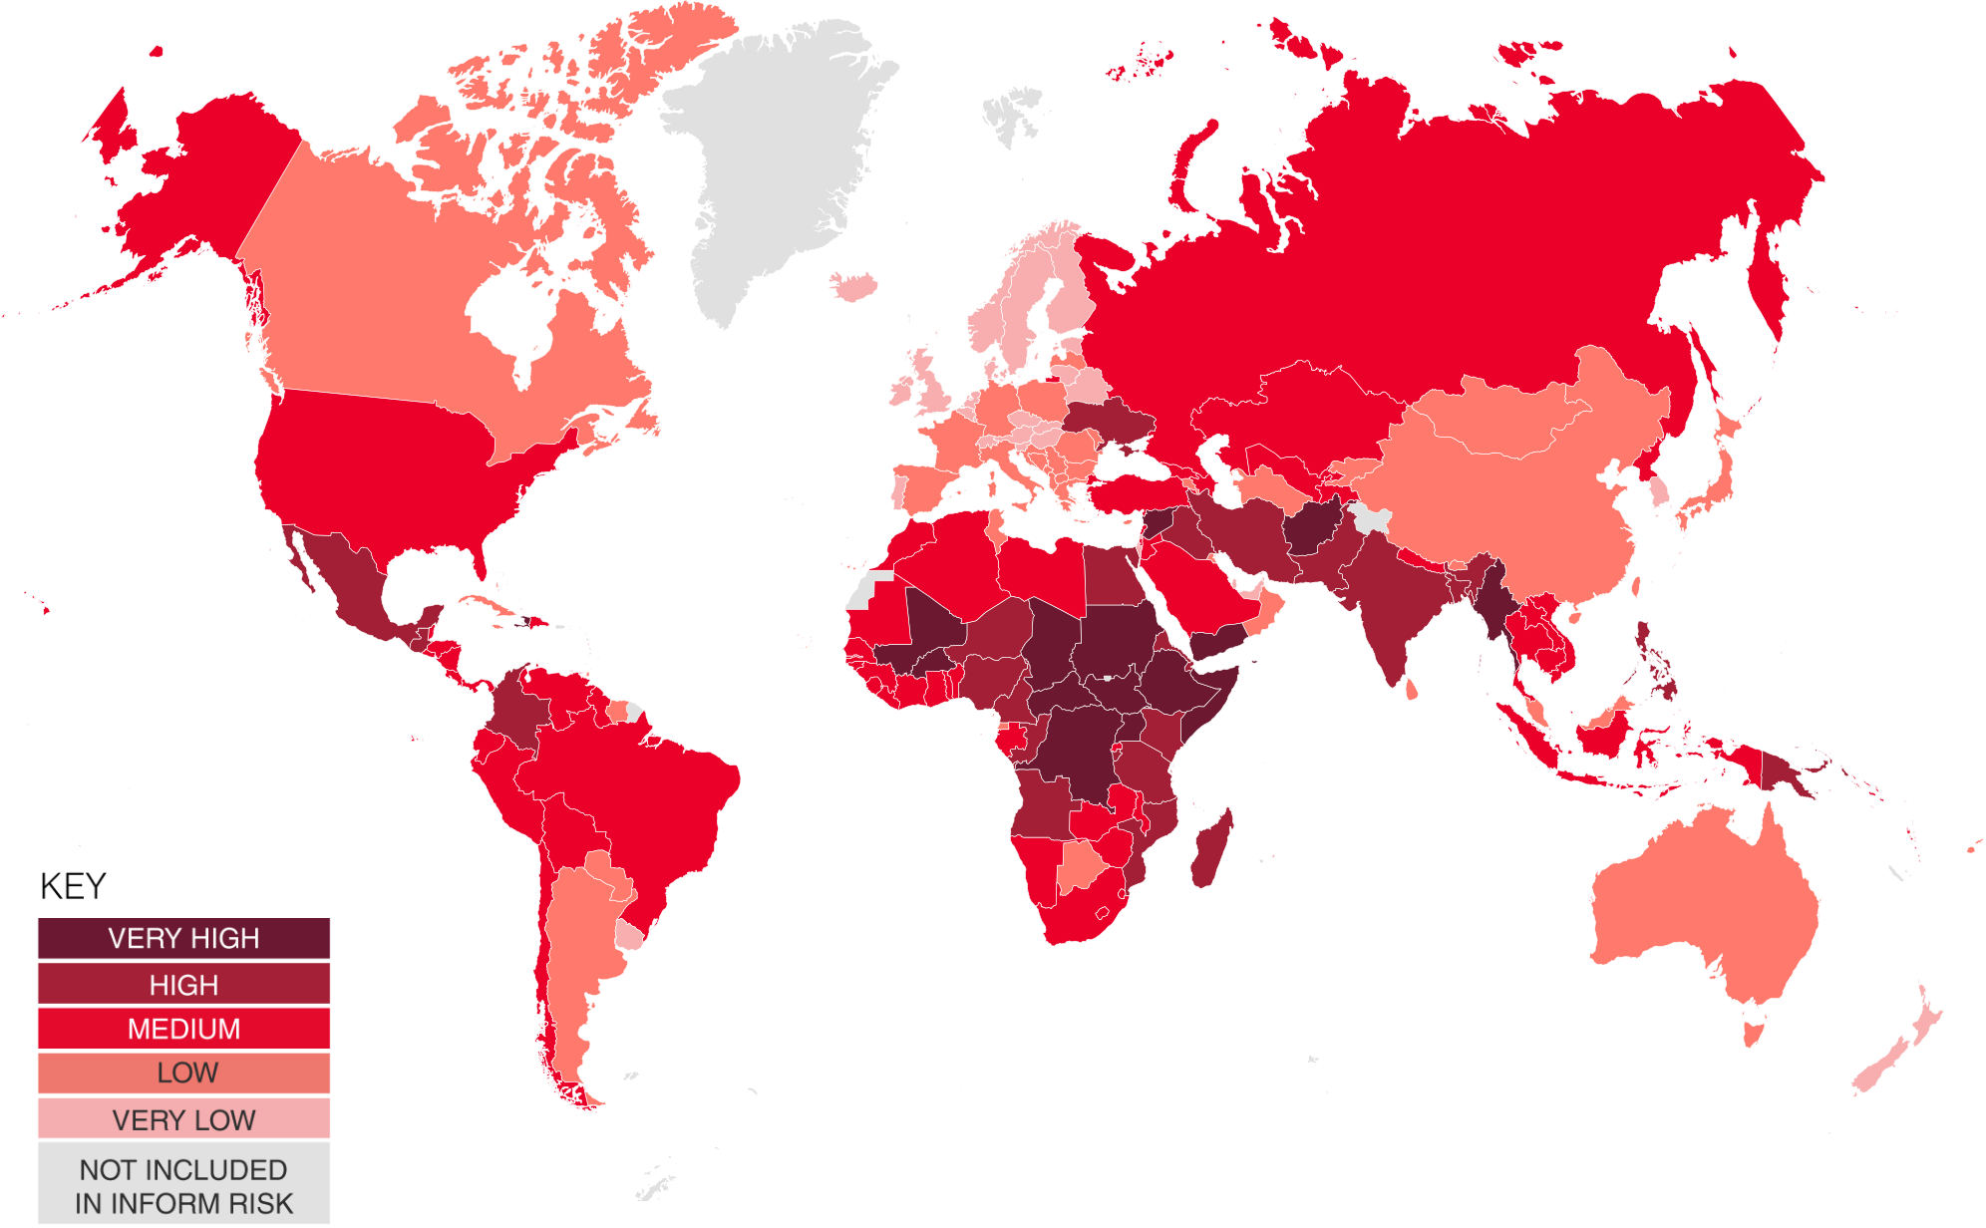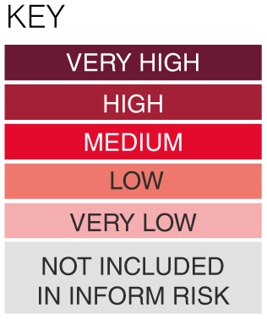

INFORM RISK INDEX 2024 RESULTS

|  |  |  |  |  |  |  |  |  |
| --- | --- | --- | --- | --- | --- | --- | --- | --- |
| COUNTRY | RISK | 3 YR | COUNTRY | RISK | 3 YR | COUNTRY | RISK | 3 YR |
| TREND | TREND | TREND |

|  |  |  |  |  |  |  |  |  |  |  |  |  |  |  |  |
| --- | --- | --- | --- | --- | --- | --- | --- | --- | --- | --- | --- | --- | --- | --- | --- |
| 21 | Afghanistan | 8.1 | Czech Republic | 1.8 | Korea DPR | 4.1 | The depiction and use of boundaries are not warranted to be error free nor do they necessarily  imply official endorsement or acceptance by the United Nations and European Union. Very High High Medium Low Very Low | | | | | | Not included in INFORM | | |
| Albania | 3.1 | Denmark | 1.4 | Korea Republic of | 1.9 |
| Algeria | 3.6 | Djibouti | 4.9 | Kuwait | 2.5 |
| Angola | 5.2 | Dominica | 3.0 | Kyrgyzstan | 3.1 |
| Antigua and Barbuda | 2.3 | Dominican Republic | 4.1 | Lao PDR | 3.5 |
| Argentina | 2.9 | Ecuador | 4.7 | Latvia | 2.4 |
| Armenia | 2.9 | Egypt | 4.9 | Lebanon | 4.1 |
| Australia | 2.4 | El Salvador | 4.0 | Lesotho | 3.6 |
| Austria | 1.9 | Equatorial Guinea | 3.1 | Liberia | 4.5 |
| Azerbaijan | 4.8 | Eritrea | 6.0 | Libya | 4.8 |
| Bahamas | 2.1 | Estonia | 1.6 | Liechtenstein | 1.0 |
| Bahrain | 1.4 | Eswatini | 3.3 | Lithuania | 1.9 |
| Bangladesh | 5.7 | Ethiopia | 7.0 | Luxembourg | 1.1 |
| Barbados | 2.0 | Fiji | 2.9 | Madagascar | 5.5 | COUNTRY | RISK | 3 YR | COUNTRY | RISK | 3 YR | COUNTRY | RISK | 3 YR |
| Belarus | 1.8 | Finland | 1.5 | Malawi | 4.4 |
| Belgium | 2.1 | France | 2.4 | Malaysia | 2.9 |
| TREND | TREND | TREND |
| Belize | 3.6 | Gabon | 3.2 | Maldives | 2.2 | New Zealand | 1.4 | Senegal | | 4.1 | | Tuvalu | 3.0 | |
| Benin | 4.3 | Gambia | 3.6 | Mali | 6.8 |
| Nicaragua | 4.1 | Serbia | | 2.9 | | Uganda | 7.0 | |
| Bhutan | 2.8 | Georgia | 3.5 | Malta | 1.7 |
| Niger | 6.6 | Seychelles | | 1.5 | | Ukraine | 5.1 | |
| Bolivia | 3.6 | Germany | 2.4 | Marshall Islands | 4.1 | Nigeria | 6.6 | Sierra Leone | | 4.2 | | United Arab Emirates | 1.7 | |
| Bosnia and Herzegovina | 3.1 | Ghana | 3.5 | Mauritania | 4.3 | North Macedonia | 2.2 | Singapore | | 0.7 | | United Kingdom | 2.1 | |
| Botswana | 2.6 | Greece | 2.6 | Mauritius | 2.1 |
| Norway | 1.7 | Slovakia | | 2.1 | | United States of America | 3.2 | |
| Brazil | 4.6 | Grenada | 2.2 | Mexico | 4.9 |
| Oman | 2.5 | Slovenia | | 1.6 | | Uruguay | 2.1 | |
| Brunei Darussalam | 2.4 | Guatemala | 5.1 | Micronesia | 3.2 | Pakistan | 6.1 | Solomon Islands | | 4.5 | | Uzbekistan | 3.2 | |
| Bulgaria | 2.7 | Guinea | 4.5 | Moldova Republic of | 3.1 | Palau | 2.7 | Somalia | | 8.5 | | Vanuatu | 4.2 | |
| Burkina Faso | 7.0 | Guinea-Bissau | 3.9 | Mongolia | 2.9 |
| Palestine | 3.7 | South Africa | | 4.5 | | Venezuela | 4.7 | |
| Burundi | 5.6 | Guyana | 3.6 | Montenegro | 2.7 |
| Panama | 3.6 | South Sudan | | 8.5 | | Viet Nam | 3.7 | |
| Cabo Verde | 2.4 | Haiti | 7.2 | Morocco | 3.6 | Papua New Guinea | 6.7 | Spain | | 2.3 | | Yemen | 7.5 | |
| Cambodia | 4.3 | Honduras | 4.8 | Mozambique | 6.7 | Paraguay | 2.7 | Sri Lanka | | 3.1 | | Zambia | 3.9 | |
| Cameroon | 6.6 | Hungary | 1.9 | Myanmar | 7.1 |
| Peru | 4.8 | Sudan | | 7.3 | | Zimbabwe | 4.1 | |
| Canada | 2.4 | Iceland | 1.6 | Namibia | 3.8 |
| Philippines | 5.3 | Suriname | | 3.0 | |
| Central African Republic | 8.7 | India | 5.3 | Nauru | 2.6 | Poland | 2.5 | Sweden | | 1.9 | |
| Chad | 7.8 | Indonesia | 4.6 | Nepal | 4.1 | Portugal | 2.0 | Switzerland | | 1.4 | |
| RISK INDEX | | |
| Chile | 3.2 | Iran | 5.4 | Netherlands | 2.1 | Qatar | 1.4 | Syria | | 7.2 | |
| China | 3.0 | Iraq | 6.7 | Romania | 2.6 | Tajikistan | | 4.4 | |
| RISK INDEX |
| Colombia | 5.3 | Ireland | 1.7 | Russian Federation | 4.4 | Tanzania | | 5.1 | |
| Comoros | 3.3 | Israel | 1.8 | Rwanda | 4.2 | Thailand | | 4.4 | |
| Congo | 5.0 | Italy | 2.5 | VERY HIGH | VERY HIGH | | |
| Saint Kitts and Nevis | 1.9 | Timor-Leste | | 3.6 | |
| HIGH | HIGH | | |
| Congo DR | 7.7 | Jamaica | 2.9 | MEDIUM | Saint Lucia | 2.8 | Togo | | 4.3 | | MEDIUM | | |
| Costa Rica | 3.2 | Japan | 2.3 | Saint Vincent and | 2.6 | Tonga | | 3.3 | | LOW | | |
| LOW |
| Côte d’Ivoire | 4.6 | Jordan | 3.8 | VERY LOW | Trinidad and Tobago | | 2.8 | | VERY LOW | | |
| the Grenadines |
| Croatia | 2.4 | Kazakhstan | 3.2 | KEY | KEY | | |
| Samoa | 3.0 | Tunisia | | 3.0 | |
| Cuba | 2.8 | Kenya | 6.6 | Increasing risk | | |
| Increasing risk | Sao Tome and Principe | 2.6 | Türkiye | | 4.8 | |
| Cyprus | 2.6 | Kiribati | 3.7 | Stable | Stable | | |
| Saudi Arabia | 3.6 | Turkmenistan | | 2.9 | |
| Decreasing risk | Decreasing risk | | |
| 22 | | |

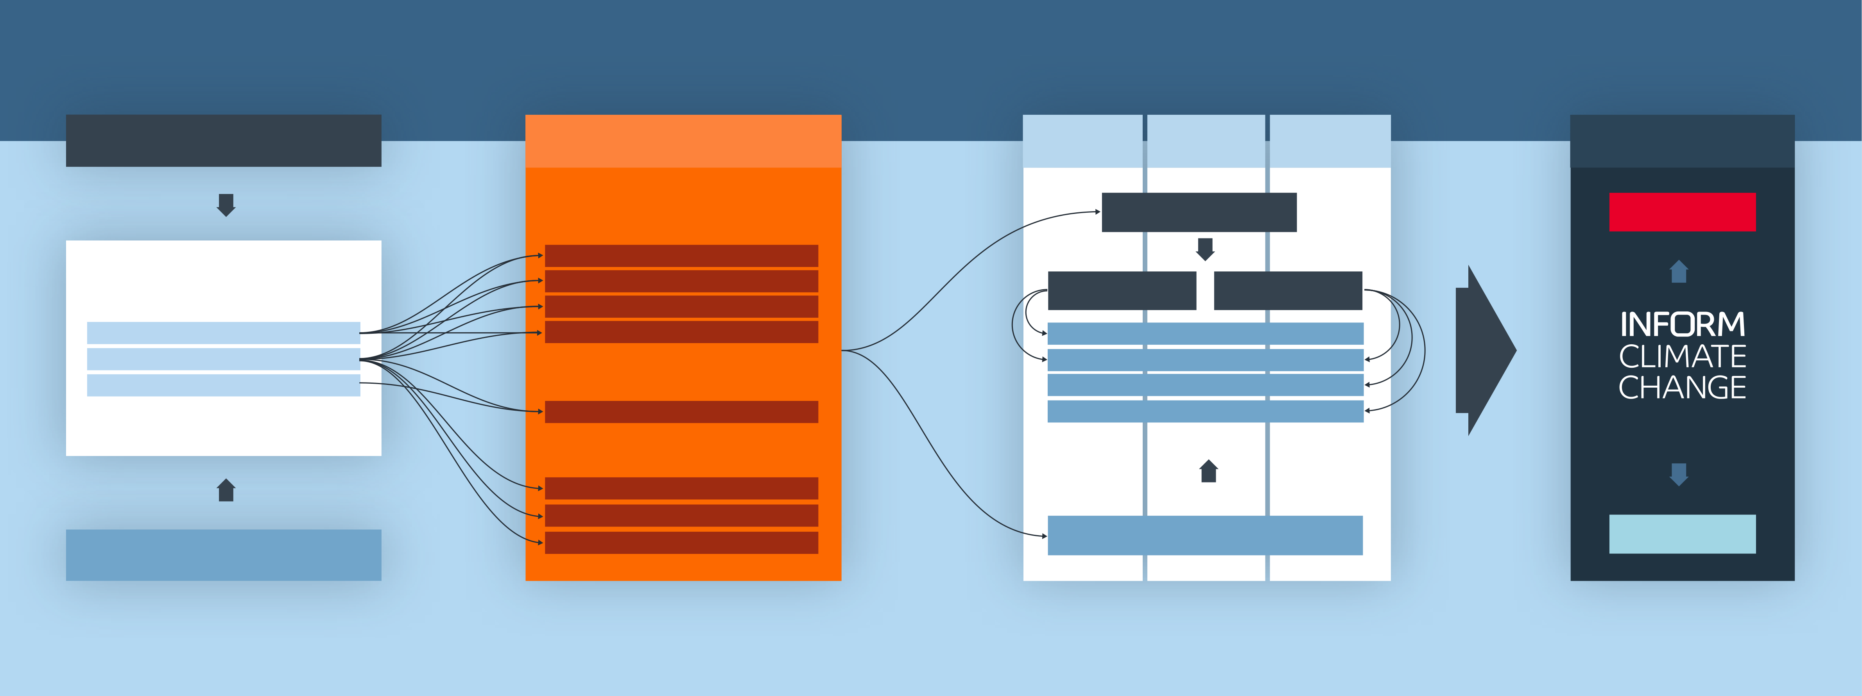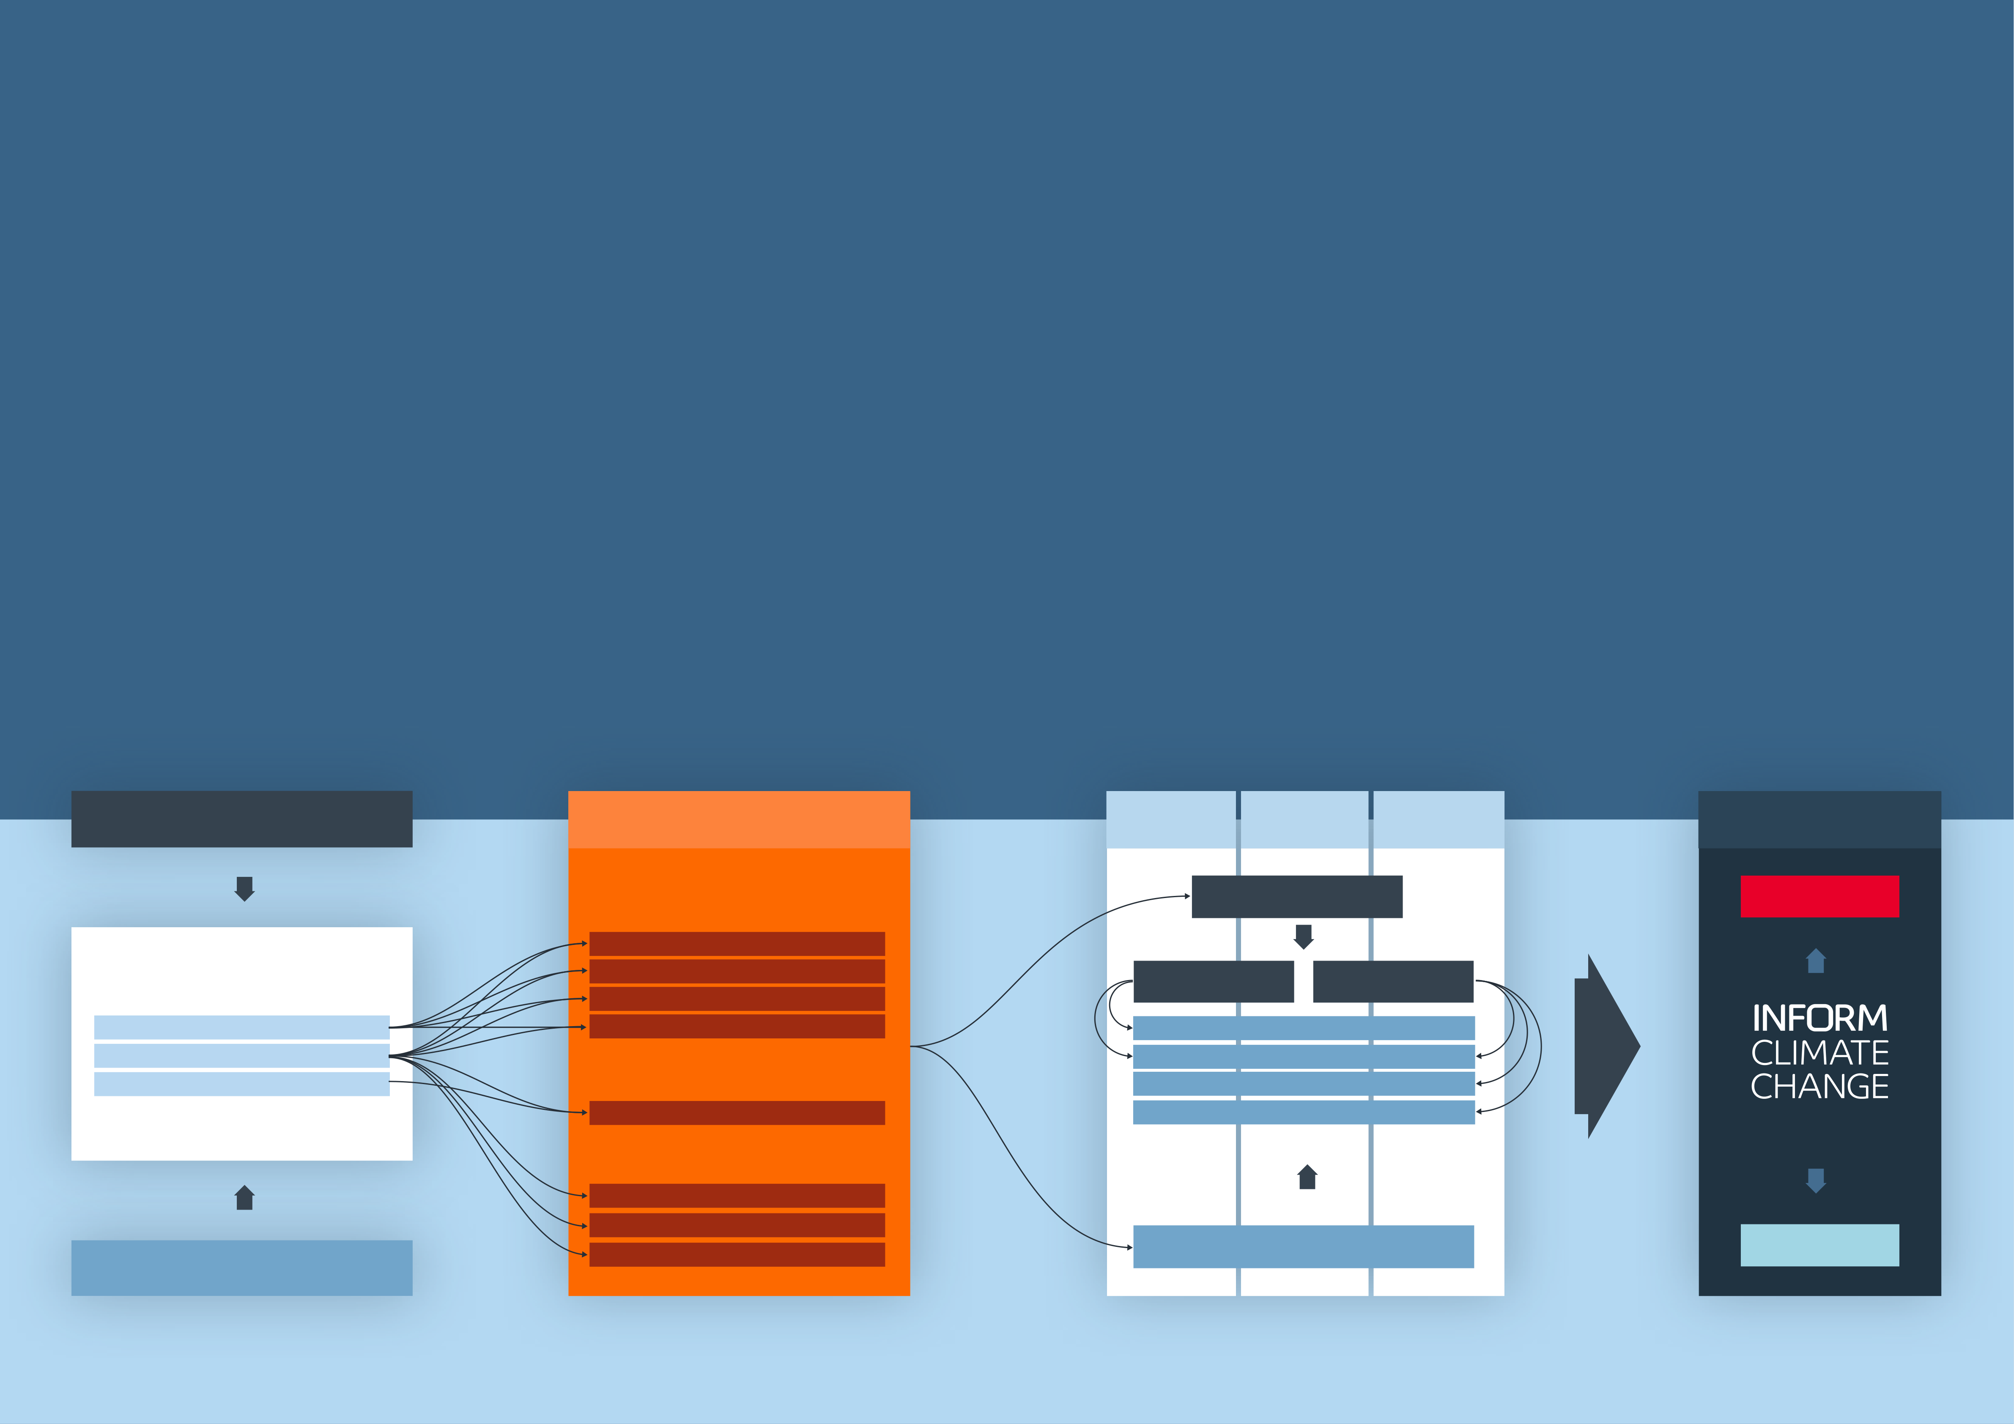

**INFORM CLIMATE CHANGE**

|  |  |  |  |
| --- | --- | --- | --- |
| INFORM Climate Change is a | **Objectives** | **How it works** | The population projections derived from SSPs |
| new INFORM product based on the | The objective of INFORM Climate Change is to inform | INFORM Climate Change incorporates climate and |
| INFORM Risk Index. It incorporates | decision-making around the risk of climate-amplified | socioeconomic projections into the methodology |
| are also applied to non-climate natural hazards |
| climate and socioeconomic projections | hazards, as well as how increased risks could be | of the INFORM Risk Index. Specifically, it uses a |
| (earthquake, tsunami) and non-modelled |
| to analyse how risk will change as a | offset by improved vulnerability and coping capacity. | combination of: | hazards (tropical cyclone wind). Tropical |
| Specifically, it is intended to: | • Representative Concentration Pathways (RCPs) | cyclone wind has not been included because |
| result of climate change under different |
| changes cannot be modelled with sufficient |
| emission and population scenarios. | • Lead to a shared and objective understanding of the | describing the evolution of future atmospheric |
| geographic accuracy. Population and other |
| greenhouse gas concentrations and other |
| INFORM Climate Change is a result | impact of climate change on the risk of humanitarian |
| radiative forcings | socioeconomic projections are used to project |
| crises |
| of collaboration between the Euro- |
| • Shared Socioeconomic Pathways (SSPs) that portray | conflict hazard. In future iterations of the tool, |
| • Support policy-making that leads to greater resilience |
| Mediterranean Center on Climate |
| changes to vulnerability may also be included. |
| to the adverse impacts of climate change | how socioeconomic factors may change over the |
| Change and Joint Research Centre |
| • Support decisions on the allocation of DRR and climate | next century | The projections are applied at different |
| of European Commission. | Together, these scenarios are used to project the | timeframes (2022, 2050, 2080) to calculate |
| adaptation resources that is consistent with SDG and |
| the Change in risk and the Vulnerability gap |
| Sendai targets | Hazard and Exposure dimension of the INFORM Risk |
| • Identify inequalities in climate impacts, for example | – the level of vulnerability reduction or coping |
| Index into the future, taking into account changes to |
| capacity increase required for a country to |
| climate-related hazards (river flood, drought, coastal |
| on marginalised groups like people on the move |
| preserve its current level of risk. |
| flood and epidemics) and the distribution of exposed |

populations. The epidemics component comprises

malaria and dengue.

|  |  |  |  |  |  |
| --- | --- | --- | --- | --- | --- |
| **Representative Concentration Pathways (RCPs)** | INFORM Risk Index Hazard | 2022 | 2050 | 2080 | Results |
| and Exposure dimension |

**Concentration Pathway**  **Change in risk**

**Climate hazards**

River Flood

|  |  |  |  |
| --- | --- | --- | --- |
| **Climate & Socioeconomic Projections** | Coastal Flood | Moderate (RCP4.5) | High (RCP8.5) |
| Drought |
| Epidemics (malaria and dengue) | Sustainability (SSP1) | |
| Hazard Projections |
| Demographic Projections | **Non-climate and non-modelled hazards** | Middle of the road (SSP2) | |
| Other Socioeconomic Projections | Regional rivalry (SSP3) | |
| Conflict | Fossil Fuel Development (SSP5) | |

SHARING CRISIS ANALYSIS

Tsunami

Cyclone

|  |  |  |  |  |  |
| --- | --- | --- | --- | --- | --- |
| 23 | **Shared Socioeconomic Pathways (SSPs)** | Earthquake | **Socioeconomic Pathway** | **Vulnerability gap** | 21 |

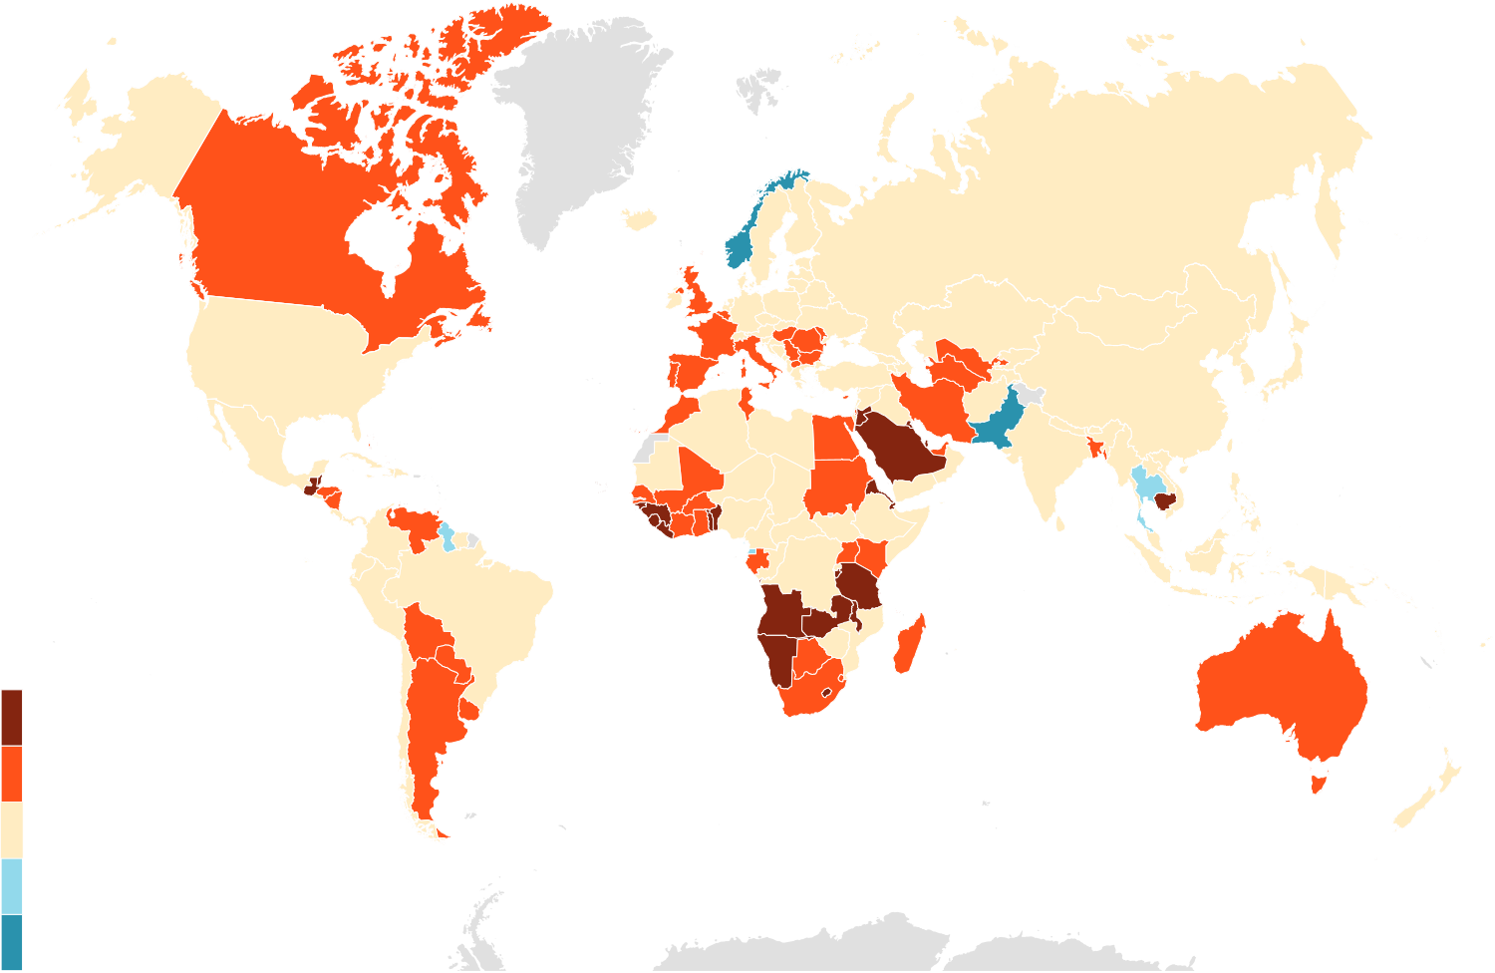

INFORM CLIMATE CHANGE RESULTS

|  |  |  |
| --- | --- | --- |
| **Interpreting the results** | |  | | --- | | **Pessimistic** climate and socio-economic scenario (RCP 8.5 + SSP3) | |

|  |  |  |
| --- | --- | --- |
| INFORM Climate Change is based on the INFORM Risk | **Change in risk (2050-baseline)** | **Vulnerability gap** |
| Index methodology, so it measures changes in the risk of a |

humanitarian crisis that could overwhelm national capacity.

|  |  |  |
| --- | --- | --- |
| The results of INFORM Climate Change include the |  |  |
| following: |
| **• INFORM Climate Change Risk Index baseline** – |
| a slightly adapted INFORM Risk Index that allows |
| comparison with future hazard projections. |
| **• INFORM Climate Change Risk Index** – this shows |
| the future risk, taking into account climate and |
| socio-economic changes for different scenarios and |
| timeframes. |
| **• Change in risk** – this shows the change in the baseline |
| risk index taking into account climate, demographic and |
| socio-economic projections. |
| **• Vulnerability Gap** – this shows the change in 1 |
| Vulnerability and Lack of Coping Capacity (see INFORM |
| Risk Index analytical framework), which would be required |
| to maintain the baseline level of risk (i.e. to compensate |
| for increases in risk due to climate, demographic and |  |  |
| socio-economic factors). |

These maps and the following tables summarise the

|  |  |  |  |
| --- | --- | --- | --- |
| change in risk and vulnerability gap for mid-century (≈2050) | |  | | --- | | **Optimistic**climate and socio-economic scenario (RCP 4.5 + SSP1) | |  |
| under both pessimistic and optimistic climate and socio- |
|  | **Change in risk (2050-baseline)** | **Vulnerability gap** |
| economic scenarios. |

For a full explanation of the methodology, scenario

|  |  |  |  |
| --- | --- | --- | --- |
| selection, results and analysis, see the **[INFORM Climate](https://drmkc.jrc.ec.europa.eu/inform-index/Portals/0/InfoRM/2022/INFORM%20Climate%20Change%20Brochure.pdf)** | |  |  |
| **[Change Report](https://drmkc.jrc.ec.europa.eu/inform-index/Portals/0/InfoRM/2022/INFORM%20Climate%20Change%20Brochure.pdf)** and **[webpage](http://drmkc.jrc.ec.europa.eu/inform-index/INFORM-Climate-Change)**. | |
| **INFORM Climate Change scenario combinations** | |
| **Pessimistic**  RCP 8.5 + SSP 3 | |  | | --- | | **Optimistic Optimistic**  RCP 4.5 + SSP 1 RCP 4.5 + SSP 1 | |  |  |
| **SSP3 envisages** | |  | | --- | | **SSP1 envisages SSP1 envisages** | | **KEY** |  |
| • relatively low income growth• low human capital investments | |  | | --- | | • global population peak • global population peak  in mid-century in mid-century | |
| • high fertility and population growth rates in currently high fertility countries | |  | | --- | | • reasonably high pace in sustainable • reasonably high pace in sustainable  development development | |
| • low or negative population growth | |  | | --- | | • lessened inequalities• lessened inequalities | |
| in currently low fertility rate countries• low migration | |  | | --- | | • rapid technological growth based • rapid technological growth based  on low carbon energy sources on low carbon energy sources | |
| LARGE INCREASE |
| • slow urbanization. | |  | | --- | | • high productivity of land.• high productivity of land. | |
| INCREASE |
| STABLE |  |



|  |  |
| --- | --- |
| DECREASE  LARGE DECREASE |  |

The depiction and use of boundaries are not warranted to be error free nor do they necessarily

|  |  |  |
| --- | --- | --- |
| 25 | imply official endorsement or acceptance by the United Nations and European Union. | 26 |

|  |  |  |  |  |  |  |  |  |  |  |  |  |  |  |  |  |  |  |  |  |  |  |  |  |  |  |  |  |  |  |  |  |  |  |  |  |  |  |  |  |  |  |  |  |  |  |  |  |  |  |  |  |  |  |  |  |  |  |  |  |  |  |  |  |  |  |  |  |  |  |  |  |  |  |  |  |  |  |  |  |  |  |  |  |  |  |  |  |  |  |  |  |  |  |  |  |  |  |  |  |  |  |  |  |  |  |  |  |  |  |  |  |  |  |  |  |  |  |  |  |  |  |  |  |  |  |  |  |  |  |  |  |  |  |  |  |  |  |  |  |  |  |  |  |  |  |  |  |  |  |  |  |  |  |  |  |  |  |  |  |  |  |  |  |  |  |  |  |  |  |  |  |  |  |  |  |  |  |  |  |  |  |  |  |  |  |  |  |  |  |  |  |  |  |  |  |  |  |  |  |  |  |  |  |  |  |  |  |  |  |  |  |  |  |  |  |  |  |  |  |  |  |  |  |  |  |  |  |  |  |  |  |  |  |  |  |  |  |  |  |  |  |  |  |  |  |  |  |  |  |  |  |  |  |  |  |  |  |  |  |  |  |  |  |  |  |  |  |  |  |  |  |  |  |  |  |  |  |  |  |  |  |  |  |  |  |  |  |  |  |  |  |  |  |  |  |  |  |  |  |  |  |  |  |  |  |  |  |  |  |  |  |  |  |  |  |  |  |  |  |  |  |  |  |  |  |  |  |  |  |  |  |  |  |  |  |  |  |  |  |  |  |  |  |  |  |  |  |  |  |  |  |  |  |  |  |
| --- | --- | --- | --- | --- | --- | --- | --- | --- | --- | --- | --- | --- | --- | --- | --- | --- | --- | --- | --- | --- | --- | --- | --- | --- | --- | --- | --- | --- | --- | --- | --- | --- | --- | --- | --- | --- | --- | --- | --- | --- | --- | --- | --- | --- | --- | --- | --- | --- | --- | --- | --- | --- | --- | --- | --- | --- | --- | --- | --- | --- | --- | --- | --- | --- | --- | --- | --- | --- | --- | --- | --- | --- | --- | --- | --- | --- | --- | --- | --- | --- | --- | --- | --- | --- | --- | --- | --- | --- | --- | --- | --- | --- | --- | --- | --- | --- | --- | --- | --- | --- | --- | --- | --- | --- | --- | --- | --- | --- | --- | --- | --- | --- | --- | --- | --- | --- | --- | --- | --- | --- | --- | --- | --- | --- | --- | --- | --- | --- | --- | --- | --- | --- | --- | --- | --- | --- | --- | --- | --- | --- | --- | --- | --- | --- | --- | --- | --- | --- | --- | --- | --- | --- | --- | --- | --- | --- | --- | --- | --- | --- | --- | --- | --- | --- | --- | --- | --- | --- | --- | --- | --- | --- | --- | --- | --- | --- | --- | --- | --- | --- | --- | --- | --- | --- | --- | --- | --- | --- | --- | --- | --- | --- | --- | --- | --- | --- | --- | --- | --- | --- | --- | --- | --- | --- | --- | --- | --- | --- | --- | --- | --- | --- | --- | --- | --- | --- | --- | --- | --- | --- | --- | --- | --- | --- | --- | --- | --- | --- | --- | --- | --- | --- | --- | --- | --- | --- | --- | --- | --- | --- | --- | --- | --- | --- | --- | --- | --- | --- | --- | --- | --- | --- | --- | --- | --- | --- | --- | --- | --- | --- | --- | --- | --- | --- | --- | --- | --- | --- | --- | --- | --- | --- | --- | --- | --- | --- | --- | --- | --- | --- | --- | --- | --- | --- | --- | --- | --- | --- | --- | --- | --- | --- | --- | --- | --- | --- | --- | --- | --- | --- | --- | --- | --- | --- | --- | --- | --- | --- | --- | --- | --- | --- | --- | --- | --- | --- | --- | --- | --- | --- | --- | --- | --- | --- | --- | --- | --- | --- | --- | --- | --- | --- | --- | --- | --- | --- | --- | --- | --- | --- | --- | --- | --- | --- | --- | --- | --- | --- | --- | --- | --- | --- | --- | --- | --- | --- |
| INFORM CLIMATE CHANGE RESULTS | |  |  |  |  |  | | --- | --- | --- | --- | --- | | **COUNTRY** | Baseline (current) risk (B) | **MID-CENTURY (≈2050) CRISIS RISK** | | | | **PESSIMISTIC (P)**  climate and socio-economic scenario | | | | INFORM CC Risk  Index 2022 | INFORM CC  Risk Index | Change in risk | Vulnerability gap | | Brunei Darussalam | 1.9 | 2.0 | 0.1 | 0.1 | | Bulgaria | 2.2 | 2.5 | 0.3 | 0.2 | | Burkina Faso | 6.4 | 6.6 | 0.2 | 0.6 | | Burundi | 5.1 | 5.8 | 0.7 | 1 .8 | | Cabo Verde | 1.9 | 2.5 | 0.6 | 0.7 | | Cambodia | 4.6 | 5.2 | 0.6 | 1 .0 | | Cameroon | 6.2 | 6.4 | 0.2 | 0.4 | | Canada | 2.5 | 2.7 | 0.2 | 0.1 | | Central African Republic | 7 .7 | 7 .8 | 0.1 | 0.4 | | Chad | 7 .8 | 7 .9 | 0.1 | 0.3 | | Chile | 3.3 | 3.5 | 0.2 | 0.2 | | China | 3.9 | 4.0 | 0.1 | 0.1 | | Colombia | 5.4 | 5.5 | 0.1 | 0.1 | | Comoros | 3.8 | 4.4 | 0.6 | 1 .4 | | Congo | 5.2 | 5.3 | 0.1 | 0.4 | | Congo DR | 7 .6 | 7 .8 | 0.2 | 0.5 | | Costa Rica | 3.2 | 3.4 | 0.2 | 0.2 | | Côte d’Ivoire | 4.7 | 5.2 | 0.5 | 1 .1 | | Croatia | 2.2 | 2.3 | 0.1 | 0.1 | | Cuba | 2.4 | 2.4 | 0.0 | 0.0 | | Cyprus | 2.6 | 2.8 | 0.2 | 0.2 | | Czech Republic | 1.2 | 1.3 | 0.1 | 0.0 | | Denmark | 1.4 | 1.5 | 0.1 | 0.1 | | Djibouti | 4.4 | 4.9 | 0.5 | 1 .2 | | Dominica | 2.6 | 2.6 | 0.0 | 0.0 | | Dominican Republic | 4.2 | 4.4 | 0.2 | 0.3 | | Ecuador | 4.4 | 4.6 | 0.2 | 0.3 | | Egypt | 4.8 | 5.0 | 0.2 | 0.2 | | El Salvador | 4.3 | 4.6 | 0.3 | 0.5 | | Equatorial Guinea | 3.8 | 3.6 | -0.2 | -0.3 | | Eritrea | 4.0 | 4.9 | 0.9 | 1 .9 | | Estonia | 1.0 | 1.0 | 0.0 | 0.0 | | Eswatini | 3.3 | 3.5 | 0.2 | 0.5 | | |  |  |  |  |  | | --- | --- | --- | --- | --- | | **COUNTRY** | Baseline (current) risk (B) | **MID-CENTURY (≈2050) CRISIS RISK** | | | | **PESSIMISTIC (P)**  climate and socio-economic scenario | | | | INFORM CC Risk  Index 2022 | INFORM CC  Risk Index | Change in risk | Vulnerability gap | | Ethiopia | 6.8 | 6.9 | 0.1 | 0.2 | | Fiji | 3.2 | 3.1 | -0.1 | -0.1 | | Finland | 1.3 | 1.4 | 0.1 | 0.1 | | France | 2.4 | 2.6 | 0.2 | 0.1 | | Gabon | 3.7 | 4.1 | 0.4 | 0.7 | | Gambia | 3.6 | 4.4 | 0.8 | 1.4 | | Georgia | 3.1 | 3.2 | 0.1 | 0.2 | | Germany | 2.4 | 2.5 | 0.1 | 0.1 | | Ghana | 4.0 | 4.4 | 0.4 | 0.6 | | Greece | 2.7 | 2.8 | 0.1 | 0.1 | | Grenada | 1.7 | 1.7 | 0.0 | 0.0 | | Guatemala | 5.1 | 5.8 | 0.7 | 1.2 | | Guinea | 4.4 | 5.0 | 0.6 | 1.2 | | Guinea-Bissau | 4.1 | 5.0 | 0.9 | 2.4 | | Guyana | 4.3 | 4.2 | -0.1 | -0.2 | | Haiti | 5.5 | 5.8 | 0.3 | 0.7 | | Honduras | 4.9 | 5.4 | 0.5 | 0.9 | | Hungary | 1.5 | 1.8 | 0.3 | 0.1 | | Iceland | 1.3 | 1.3 | 0.0 | 0.0 | | India | 5.5 | 5.5 | 0.0 | 0.1 | | Indonesia | 4.4 | 4.7 | 0.3 | 0.2 | | Iran | 4.3 | 4.8 | 0.5 | 0.7 | | Iraq | 6.6 | 6.6 | 0.0 | 0.2 | | Ireland | 1.7 | 1.7 | 0.0 | 0.0 | | Israel | 2.6 | 2.7 | 0.1 | 0.1 | | Italy | 2.5 | 2.7 | 0.2 | 0.1 | | Jamaica | 3.0 | 3.2 | 0.2 | 0.2 | | Japan | 2.3 | 2.3 | 0.0 | 0.0 | | Jordan | 3.5 | 4.1 | 0.6 | 1.2 | | Kazakhstan | 1.6 | 1.8 | 0.2 | 0.1 | | Kenya | 4.6 | 5.1 | 0.5 | 1.0 | | Kiribati | 3.0 | 3.7 | 0.7 | 1.5 | | Korea DPR | 4.6 | 4.7 | 0.1 | 0.3 | |
| This table shows top level results from INFORM Climate Change: the current |
| INFORM Climate Change Risk Index, and – for mid-century (≈2050) under |
| the pessimistic climate and socio-economic scenario – the INFORM Climate |
| Change Risk Index, the change in risk and the vulnerability gap. |
| |  |  |  |  |  | | --- | --- | --- | --- | --- | | **COUNTRY** | Baseline (current) risk (B) | **MID-CENTURY (≈2050) CRISIS RISK** | | | | **PESSIMISTIC (P)**  climate and socio-economic scenario | | | | INFORM CC Risk  Index 2022 | INFORM CC  Risk Index | Change in risk | Vulnerability gap | | Afghanistan | 8.0 | 8.1 | 0.1 | 0.2 | | Albania | 2.6 | 2.7 | 0.1 | 0.1 | | Algeria | 3.9 | 4.1 | 0.2 | 0.2 | | Angola | 4.5 | 5.4 | 0.9 | 1 .8 | | Antigua and Barbuda | 2.0 | 2.2 | 0.2 | 0.2 | | Argentina | 2.9 | 3.2 | 0.3 | 0.2 | | Armenia | 5.3 | 5.4 | 0.1 | 0.1 | | Australia | 2.4 | 2.6 | 0.2 | 0.1 | | Austria | 1.9 | 2.0 | 0.1 | 0.1 | | Azerbaijan | 5.8 | 5.9 | 0.1 | 0.1 | | Bahamas | 1.9 | 2.2 | 0.3 | 0.2 | | Bahrain | 1.1 | 1.4 | 0.3 | 0.2 | | Bangladesh | 5.5 | 5.9 | 0.4 | 0.5 | | Barbados | 1.8 | 1.8 | 0.0 | -0.0 | | Belarus | 1.4 | 1.6 | 0.2 | 0.1 | | Belgium | 1.9 | 2.0 | 0.1 | 0.1 | | Belize | 3.3 | 3.7 | 0.4 | 0.6 | | Benin | 4.1 | 4.9 | 0.8 | 1 .8 | | Bhutan | 3.2 | 3.3 | 0.1 | 0.3 | | Bolivia | 3.5 | 3.9 | 0.4 | 0.7 | | Bosnia and Herzegovina | 3.1 | 3.3 | 0.2 | 0.3 | | Botswana | 2.9 | 3.3 | 0.4 | 0.6 | | Brazil | 5.0 | 5.1 | 0.1 | 0.0 | |

|  |  |  |  |  |  |  |
| --- | --- | --- | --- | --- | --- | --- |
| **KEY** | CLIMATE CHANGE RISK INDEX | **VERY HIGH** | **HIGH** | **MEDIUM** | **LOW** | **VERY LOW** |

Note that because category thresholds are calculated to two decimal places, the same result rounded to one decima place can appear in different categories.

|  |  |  |  |  |  |
| --- | --- | --- | --- | --- | --- |
| CHANGE IN RISK / VULNERABILTY GAP | **LARGE INCREASE** | **INCREASE** | **STABLE** | **DECREASE** | **LARGE DECREASE** |

27 28

|  |  |  |  |  |  |  |  |  |  |  |  |  |  |  |  |  |  |  |  |  |  |  |  |  |  |  |  |  |  |  |  |  |  |  |  |  |  |  |  |  |  |  |  |  |  |  |  |  |  |  |  |  |  |  |  |  |  |  |  |  |  |  |  |  |  |  |  |  |  |  |  |  |  |  |  |  |  |  |  |  |  |  |  |  |  |  |  |  |  |  |  |  |  |  |  |  |  |  |  |  |  |  |  |  |  |  |  |  |  |  |  |  |  |  |  |  |  |  |  |  |  |  |  |  |  |  |  |  |  |  |  |  |  |  |  |  |  |  |  |  |  |  |  |  |  |  |  |  |  |  |  |  |  |  |  |  |  |  |  |  |  |  |  |  |  |  |  |  |  |  |  |  |  |  |  |  |  |  |  |  |  |  |  |  |  |  |  |  |  |  |  |  |  |  |  |  |  |  |  |  |  |  |  |  |  |  |  |  |  |  |  |  |  |  |  |  |  |  |  |  |  |  |  |  |  |  |  |  |  |  |  |  |  |  |  |  |  |  |  |  |  |  |  |  |  |  |  |  |  |  |  |  |  |  |  |  |  |  |  |  |  |  |  |  |  |  |  |  |  |  |  |  |  |  |  |  |  |  |  |  |  |  |  |  |  |  |  |  |  |  |  |  |  |  |  |  |  |  |  |  |  |  |  |  |  |  |  |  |  |  |  |  |  |  |  |  |  |  |  |  |  |  |  |  |  |  |  |  |  |  |  |  |  |  |  |  |  |  |  |  |  |  |  |  |  |  |  |  |  |  |  |  |  |  |  |  |  |  |  |  |  |  |  |  |  |  |  |  |  |  |  |  |  |  |  |  |  |  |  |  |  |  |  |  |  |  |  |  |  |  |  |  |  |  |  |  |  |  |  |  |  |  |  |  |  |  |  |  |  |  |  |  |  |  |  |  |  |  |  |  |  |  |  |  |  |  |  |  |  |  |  |  |  |  |  |  |  |  |  |  |  |  |  |  |  |  |  |  |  |  |  |  |  |  |  |  |  |  |  |  |  |  |  |  |  |  |  |  |  |  |  |  |  |  |  |  |  |  |  |  |  |  |  |  |  |  |  |  |  |  |  |  |  |  |  |  |  |  |  |  |  |  |  |  |  |  |  |  |  |  |  |  |  |  |  |  |  |  |  |  |  |  |  |  |  |  |  |  |  |  |  |  |  |  |  |  |  |  |  |  |  |  |  |  |  |  |  |  |
| --- | --- | --- | --- | --- | --- | --- | --- | --- | --- | --- | --- | --- | --- | --- | --- | --- | --- | --- | --- | --- | --- | --- | --- | --- | --- | --- | --- | --- | --- | --- | --- | --- | --- | --- | --- | --- | --- | --- | --- | --- | --- | --- | --- | --- | --- | --- | --- | --- | --- | --- | --- | --- | --- | --- | --- | --- | --- | --- | --- | --- | --- | --- | --- | --- | --- | --- | --- | --- | --- | --- | --- | --- | --- | --- | --- | --- | --- | --- | --- | --- | --- | --- | --- | --- | --- | --- | --- | --- | --- | --- | --- | --- | --- | --- | --- | --- | --- | --- | --- | --- | --- | --- | --- | --- | --- | --- | --- | --- | --- | --- | --- | --- | --- | --- | --- | --- | --- | --- | --- | --- | --- | --- | --- | --- | --- | --- | --- | --- | --- | --- | --- | --- | --- | --- | --- | --- | --- | --- | --- | --- | --- | --- | --- | --- | --- | --- | --- | --- | --- | --- | --- | --- | --- | --- | --- | --- | --- | --- | --- | --- | --- | --- | --- | --- | --- | --- | --- | --- | --- | --- | --- | --- | --- | --- | --- | --- | --- | --- | --- | --- | --- | --- | --- | --- | --- | --- | --- | --- | --- | --- | --- | --- | --- | --- | --- | --- | --- | --- | --- | --- | --- | --- | --- | --- | --- | --- | --- | --- | --- | --- | --- | --- | --- | --- | --- | --- | --- | --- | --- | --- | --- | --- | --- | --- | --- | --- | --- | --- | --- | --- | --- | --- | --- | --- | --- | --- | --- | --- | --- | --- | --- | --- | --- | --- | --- | --- | --- | --- | --- | --- | --- | --- | --- | --- | --- | --- | --- | --- | --- | --- | --- | --- | --- | --- | --- | --- | --- | --- | --- | --- | --- | --- | --- | --- | --- | --- | --- | --- | --- | --- | --- | --- | --- | --- | --- | --- | --- | --- | --- | --- | --- | --- | --- | --- | --- | --- | --- | --- | --- | --- | --- | --- | --- | --- | --- | --- | --- | --- | --- | --- | --- | --- | --- | --- | --- | --- | --- | --- | --- | --- | --- | --- | --- | --- | --- | --- | --- | --- | --- | --- | --- | --- | --- | --- | --- | --- | --- | --- | --- | --- | --- | --- | --- | --- | --- | --- | --- | --- | --- | --- | --- | --- | --- | --- | --- | --- | --- | --- | --- | --- | --- | --- | --- | --- | --- | --- | --- | --- | --- | --- | --- | --- | --- | --- | --- | --- | --- | --- | --- | --- | --- | --- | --- | --- | --- | --- | --- | --- | --- | --- | --- | --- | --- | --- | --- | --- | --- | --- | --- | --- | --- | --- | --- | --- | --- | --- | --- | --- | --- | --- | --- | --- | --- | --- | --- | --- | --- | --- | --- | --- | --- | --- | --- | --- | --- | --- | --- | --- | --- | --- | --- | --- | --- | --- | --- | --- | --- | --- | --- | --- | --- | --- | --- | --- | --- | --- | --- | --- | --- | --- | --- | --- | --- | --- | --- | --- | --- | --- | --- | --- | --- | --- | --- | --- | --- | --- | --- | --- | --- | --- | --- | --- | --- | --- | --- | --- | --- | --- | --- | --- | --- | --- | --- | --- | --- | --- | --- | --- | --- | --- | --- | --- | --- | --- | --- | --- | --- | --- | --- | --- | --- | --- | --- | --- | --- | --- | --- | --- | --- | --- | --- | --- | --- | --- | --- | --- | --- | --- | --- | --- | --- | --- | --- | --- | --- | --- | --- | --- | --- | --- | --- | --- | --- | --- | --- | --- | --- | --- | --- | --- | --- | --- | --- | --- | --- | --- | --- | --- |
| |  |  |  |  |  | | --- | --- | --- | --- | --- | | **COUNTRY** | Baseline (current) risk (B) | **MID-CENTURY (≈2050) CRISIS RISK** | | | | **PESSIMISTIC (P)**  climate and socio-economic scenario | | | | INFORM CC Risk  Index 2022 | INFORM CC  Risk Index | Change in risk | Vulnerability gap | | Korea Republic of | 2.1 | 2.1 | 0.0 | 0.0 | | Kuwait | 1.7 | 2.2 | 0.5 | 0.4 | | Kyrgyzstan | 2.7 | 2.8 | 0.1 | 0.1 | | Lao PDR | 4.0 | 4.0 | 0.0 | -0.1 | | Latvia | 1.3 | 1.4 | 0.1 | 0.1 | | Lebanon | 3.9 | 4.2 | 0.3 | 0.5 | | Lesotho | 3.0 | 3.7 | 0.7 | 2.1 | | Liberia | 5.3 | 6.0 | 0.7 | 1 .8 | | Libya | 6.2 | 6.3 | 0.1 | 0.1 | | Liechtenstein | 1.1 | 1.1 | 0.0 | 0.0 | | Lithuania | 1.4 | 1.5 | 0.1 | 0.0 | | Luxembourg | 1.1 | 1.2 | 0.1 | 0.1 | | Madagascar | 5.2 | 5.7 | 0.5 | 1 .0 | | Malawi | 4.5 | 5.1 | 0.6 | 1 .4 | | Malaysia | 3.4 | 3.5 | 0.1 | 0.1 | | Maldives | 2.1 | 2.2 | 0.1 | 0.2 | | Mali | 6.9 | 7 .1 | 0.2 | 0.3 | | Malta | 1.5 | 1.5 | 0.0 | 0.0 | | Marshall Islands | 3.1 | 3.5 | 0.4 | 0.9 | | Mauritania | 4.6 | 5.0 | 0.4 | 1 .2 | | Mauritius | 2.1 | 2.2 | 0.1 | 0.0 | | Mexico | 5.0 | 5.0 | 0.0 | 0.1 | | Micronesia | 2.9 | 3.0 | 0.1 | 0.2 | | Moldova Republic of | 2.3 | 2.6 | 0.3 | 0.3 | | Mongolia | 2.4 | 2.6 | 0.2 | 0.2 | | Montenegro | 2.2 | 2.2 | 0.0 | 0.0 | | Morocco | 3.5 | 4.1 | 0.6 | 0.6 | | Mozambique | 7 .2 | 7 .3 | 0.1 | 0.2 | | Myanmar | 6.2 | 6.3 | 0.1 | 0.2 | | Namibia | 3.2 | 3.7 | 0.5 | 1 .0 | | Nauru | 2.4 | 2.4 | 0.0 | 0.0 | | Nepal | 4.5 | 5.0 | 0.5 | 0.8 | | Netherlands | 2.0 | 2.0 | 0.0 | 0.0 | | New Zealand | 1.6 | 1.7 | 0.1 | 0.0 | | |  |  |  |  |  | | --- | --- | --- | --- | --- | | **COUNTRY** | Baseline (current) risk (B) | **MID-CENTURY (≈2050) CRISIS RISK** | | | | **PESSIMISTIC (P)**  climate and socio-economic scenario | | | | INFORM CC Risk  Index 2022 | INFORM CC  Risk Index | Change in risk | Vulnerability gap | | Nicaragua | 4.3 | 4.7 | 0.4 | 0.6 | | Niger | 7.3 | 7.5 | 0.2 | 0.3 | | Nigeria | 6.6 | 6.7 | 0.1 | 0.2 | | North Macedonia | 2.1 | 2.3 | 0.2 | 0.2 | | Norway | 1.9 | 1.7 | -0.2 | -0.2 | | Oman | 2.4 | 2.6 | 0.2 | 0.2 | | Pakistan | 6.0 | 5.9 | -0.1 | -0.1 | | Palau | 2.5 | 2.6 | 0.1 | 0.2 | | Palestine | 3.4 | 3.8 | 0.4 | 0.9 | | Panama | 3.8 | 3.9 | 0.1 | 0.2 | | Papua New Guinea | 5.5 | 5.8 | 0.3 | 0.7 | | Paraguay | 2.7 | 3.1 | 0.4 | 0.5 | | Peru | 4.5 | 4.8 | 0.3 | 0.5 | | Philippines | 5.3 | 5.4 | 0.1 | 0.1 | | Poland | 1.7 | 1.9 | 0.2 | 0.1 | | Portugal | 1.7 | 1.9 | 0.2 | 0.1 | | Qatar | 1.2 | 1.9 | 0.7 | 0.3 | | Romania | 2.1 | 2.4 | 0.3 | 0.2 | | Russian Federation | 3.3 | 3.3 | 0.0 | -0.0 | | Rwanda | 4.7 | 5.4 | 0.7 | 1 .1 | | Saint Kitts and Nevis | 1.9 | 1.9 | 0.0 | 0.0 | | Saint Lucia | 1.9 | 1.9 | 0.0 | 0.0 | | Saint Vincent and the Grenadines | 2.4 | 2.4 | 0.0 | -0.1 | | Samoa | 3.0 | 3.0 | 0.0 | 0.0 | | Sao Tome and Principe | 1.9 | 2.4 | 0.5 | 1 .4 | | Saudi Arabia | 2.1 | 2.6 | 0.5 | 0.3 | | Senegal | 4.5 | 5.2 | 0.7 | 1 .2 | | Serbia | 2.4 | 2.7 | 0.3 | 0.2 | | Seychelles | 1.8 | 1.7 | -0.1 | -0.1 | | Sierra Leone | 4.7 | 5.3 | 0.6 | 1 .3 | | Singapore | 0.6 | 0.7 | 0.1 | 0.0 | | Slovakia | 1.5 | 1.7 | 0.2 | 0.1 | | Slovenia | 1.3 | 1.3 | 0.0 | 0.0 | | Solomon Islands | 4.1 | 4.3 | 0.2 | 0.4 | | |  |  |  |  |  | | --- | --- | --- | --- | --- | | **COUNTRY** | Baseline (current) risk (B) | **MID-CENTURY (≈2050) CRISIS RISK** | | | | **PESSIMISTIC (P)**  climate and socio-economic scenario | | | | INFORM CC Risk  Index 2022 | INFORM CC  Risk Index | Change in risk | Vulnerability gap | | Somalia | 8.8 | 8.8 | 0.0 | 0.2 | | South Africa | 3.7 | 4.3 | 0.6 | 0.8 | | South Sudan | 8.5 | 8.6 | 0.1 | 0.3 | | Spain | 2.2 | 2.5 | 0.3 | 0.1 | | Sri Lanka | 3.4 | 3.6 | 0.2 | 0.2 | | Sudan | 6.4 | 6.6 | 0.2 | 0.4 | | Suriname | 3.5 | 3.7 | 0.2 | 0.2 | | Sweden | 1.8 | 1.9 | 0.1 | 0.1 | | Switzerland | 1.5 | 1.5 | 0.0 | 0.0 | | Syria | 7 .0 | 7 .0 | 0.0 | 0.1 | | Tajikistan | 3.4 | 3.6 | 0.2 | 0.3 | | Tanzania | 4.9 | 5.6 | 0.7 | 1.5 | | Thailand | 4.1 | 4.1 | 0.0 | 0.0 | | Timor-Leste | 4.5 | 4.6 | 0.1 | 0.3 | | Togo | 4.1 | 4.8 | 0.7 | 1.6 | | Tonga | 3.2 | 3.2 | 0.0 | 0.0 | | Trinidad and Tobago | 2.6 | 2.9 | 0.3 | 0.3 | | Tunisia | 3.0 | 3.3 | 0.3 | 0.3 | | Türkiye | 4.9 | 4.9 | 0.0 | 0.0 | | Turkmenistan | 2.0 | 2.3 | 0.3 | 0.3 | | Tuvalu | 2.7 | 2.7 | 0.0 | 0.0 | | Uganda | 6.2 | 6.6 | 0.4 | 0.9 | | Ukraine | 4.5 | 4.6 | 0.1 | 0.1 | | United Arab Emirates | 1.6 | 1.8 | 0.2 | 0.1 | | United Kingdom | 2.0 | 2.4 | 0.4 | 0.1 | | United States of America | 3.1 | 3.2 | 0.1 | 0.1 | | Uruguay | 2.1 | 2.3 | 0.2 | 0.2 | | Uzbekistan | 2.5 | 2.9 | 0.4 | 0.3 | | Vanuatu | 4.0 | 4.1 | 0.1 | 0.4 | | Venezuela | 4.2 | 4.6 | 0.4 | 0.5 | | Viet Nam | 3.7 | 3.8 | 0.1 | 0.1 | | Yemen | 8.1 | 8.2 | 0.1 | 0.3 | | Zambia | 4.2 | 5.0 | 0.8 | 1.7 | | Zimbabwe | 4.4 | 4.6 | 0.2 | 0.5 | |

|  |  |  |  |  |  |  |
| --- | --- | --- | --- | --- | --- | --- |
| **KEY** | CLIMATE CHANGE RISK INDEX | **VERY HIGH** | **HIGH** | **MEDIUM** | **LOW** | **VERY LOW** |

Note that because category thresholds are calculated to two decimal places, the same result rounded to one decima place can appear in different categories.

|  |  |  |  |  |  |
| --- | --- | --- | --- | --- | --- |
| CHANGE IN RISK / VULNERABILTY GAP | **LARGE INCREASE** | **INCREASE** | **STABLE** | **DECREASE** | **LARGE DECREASE** |

29 30



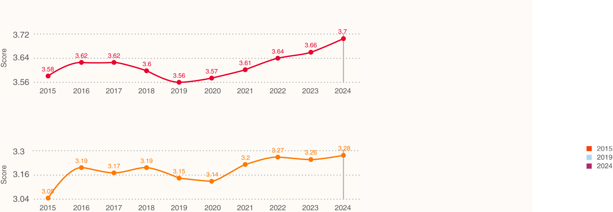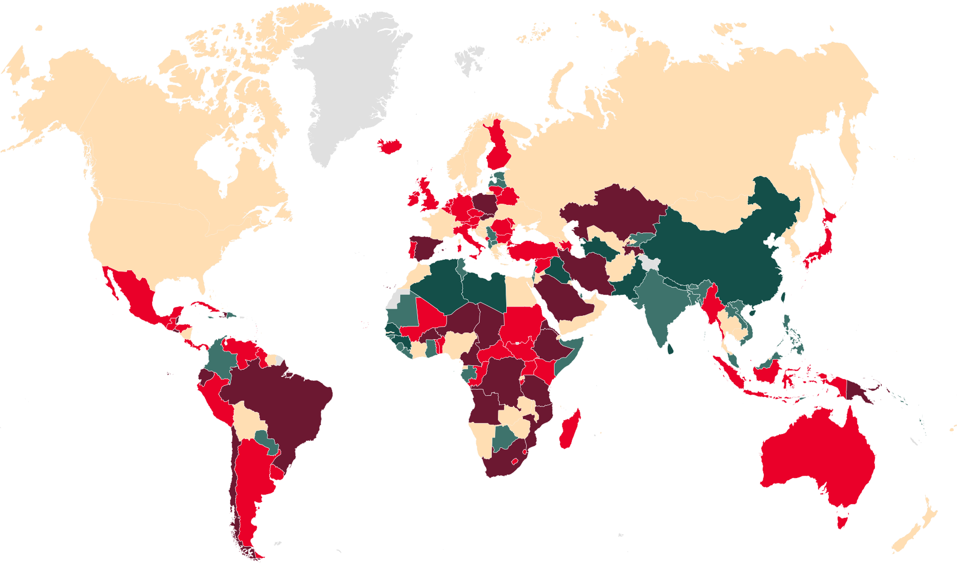

|  |
| --- |
| 10-YEAR TRENDS IN GLOBAL RISK |

Over the last ten years (INFORM Risk Index 2015-2024), there has been a general increase in the risk of humanitarian crises at global level. While there has been an improvement in coping capacity, this has been negated by large increases in the number of people exposed to hazards, and to their vulnerability. The development of institutions and infrastructure has helped decrease risks, but this has not kept pace with the increased exposure to natural hazards and conflict, combined with socioeconomic challenges.

During the last decade, conflict, displacement and shocks like the Covid-19 crisis were important drivers of increasing crisis risk. There is a noticeable increase in vulnerability and risk after 2020 that coincides with the timing of the Covid-19 pandemic and its effects. According to Global Humanitarian Overview 2023, the effects of the pandemic have triggered food and energy price increases in crisis-affected countries. The effect of such price increases on vulnerable people could be one mechanism through which the structural impacts of the pandemic continue to increase broader crisis risks.

**Global trends in the INFORM Risk Index and its dimensions 2015-2024**

|  |
| --- |
| INFORM Risk Index Average Trend |

|  |
| --- |
| Hazard & Exposure Index Average Trend |

|  |
| --- |
| Vulnerability Index Average Trend |

|  |
| --- |
|  |

Lack of Coping Capacity Index Average Trend

|  |
| --- |
|  |

33

10-YEAR TRENDS IN REGIONAL RISK

|  |  |
| --- | --- |
| Over the last 10 years, there has been an increase in the average risk of crises in all regions except Asia.  The largest increase has been in the Americas and can be attributed to considerable increases in Human Hazard and Uprooted People. There have been considerable improvements in Coping Capacity in the region, mainly related to Infrastructure. However, these could not keep pace with other dimensions.  The decrease in risk in Asia is due to a considerable decrease in Socioeconomic Vulnerability and improved | Africa remains the highest risk region and where 10 out of 15 of the highest risk countries are located. This is due to large underperformance in Hazard and Exposure and Vulnerability dimensions. There has been a large increase in Human Hazards and particular vulnerabilities relating to both Socioeconomic conditions and Vulnerable Groups.  Europe has experienced a sharp increase in risk since 2022 (dramatic increase in displacement figures). Oceania has experienced increases in natural and human hazard, and vulnerable groups (uprooted people and health conditions). |

Coping Capacity, especially the Infrastructure component.

This has counteracted an increase in emerging hazards.

**Regional trends in the INFORM Risk Index 2015-2019-2024**

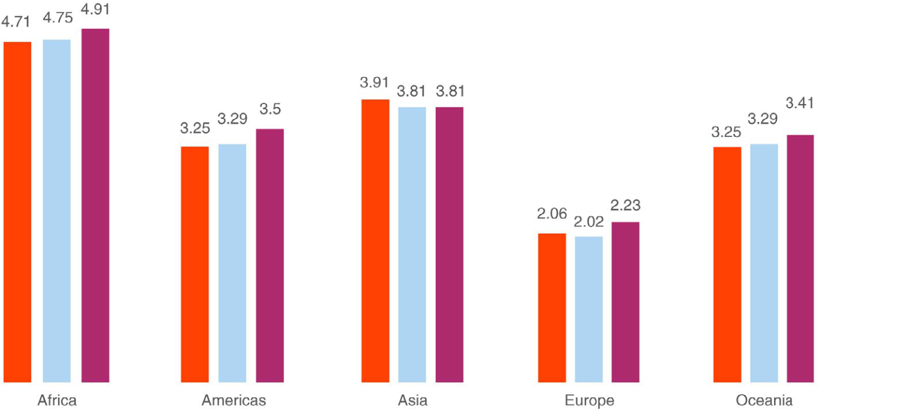

**Changes in the INFORM Risk Index 2015-2024**

**Risk trend 2015-2024**

|  |  |  |
| --- | --- | --- |
|  | Large decrease **Risk trend 2015-2024**  Decrease  Stable Large decrease  Increase Decrease | 34 |
|  |
|  |
| |  | | --- | |  | |
| |  | | --- | |  | | Large increase Stable  Not included in INFORM  Increase |
| Large increase |

Not included in INFORM

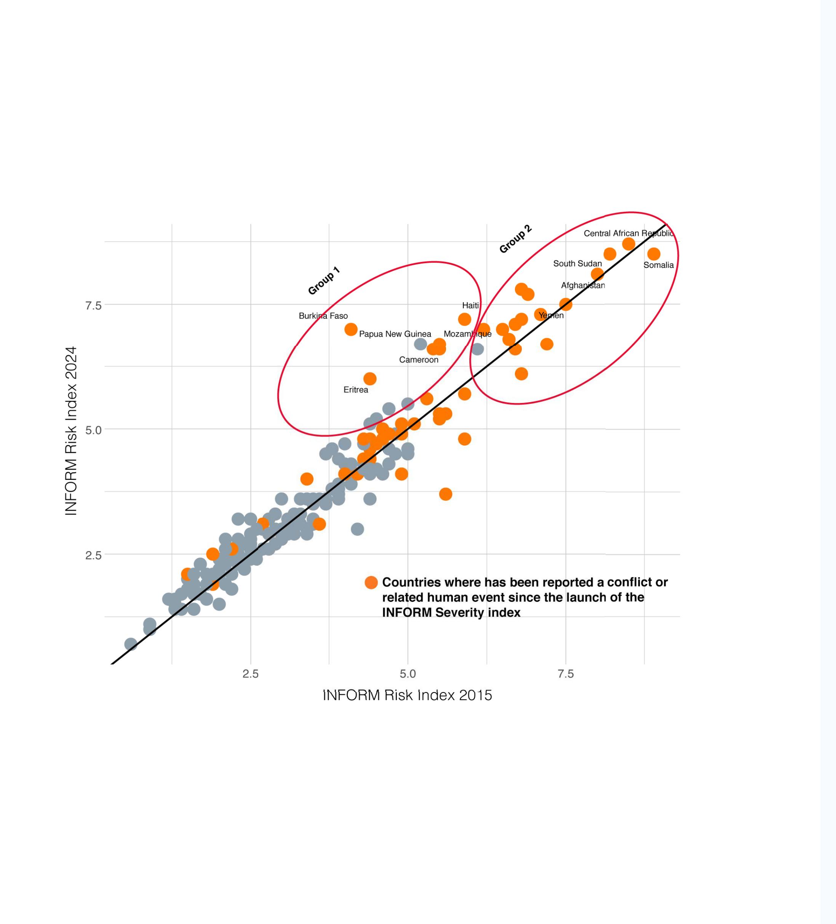

GLOBAL RISK TRENDS Crisis drivers

The majority of crises (>70%) tracked by the INFORM Severity Index since its launch in 2020 are driven by human factors (displacement, conflict, violence, political instability). The main changes in the country-level risk of humanitarian crisis over the last 10 years (INFORM Risk Index 2015-2024) are largely correlated with changes in the Human Hazard (conflict, violence, political instability). Countries not affected by human hazards experienced minimal changes. Human Hazards are the major drivers of large increases in risk (Group 1, below) and highly elevated risk (Group 2), over the last 10 years. The average risk is almost two times higher in countries facing conflicts, violence and political instability.

**Comparison of country risk levels in 2015 and 2024, according to the INFORM Risk Index. Highlighted countries are those where a conflict or related human-hazard event has been recorded in the INFORM Severity Index since 2020. Group 1 – countries experiencing large increases in risk between 2015 and 2024. Group 2 – countries with very high levels of risk. Countries experiencing conflict are over-represented in both groups.**

35

|  |
| --- |
| Human Hazards have increased in both conflict and non-conflict affected countries over the last 10 years. Furthermore, the |

direct and indirect impacts of conflict, violence and political instability propagate through all dimensions of risk. Countries affected by conflict have much higher levels of Socio-economic Vulnerability and much higher vulnerability relating to Vulnerable Groups. They also have a large underperformance in Institutional and Infrastructural Coping Capacity. Countries in conflict also have a larger than average exposure to Natural Hazards, possible evidence of cross-correlation between natural hazards, exposure to them and conflict.

|  |
| --- |
|  |

**Trends in average score for different categories of the INFORM Risk Index (2015-2019-2024), separated into groups of countries affected by conflict (tagged conflict, violence or political instability driver in INFORM Severity Index) and not affected by conflict. The direct and indirect impacts of conflict propagate through all dimensions of risk.**

|  |
| --- |
|  |

**Drivers of crises in the INFORM Severity Index, since its launch in 2020.**

36

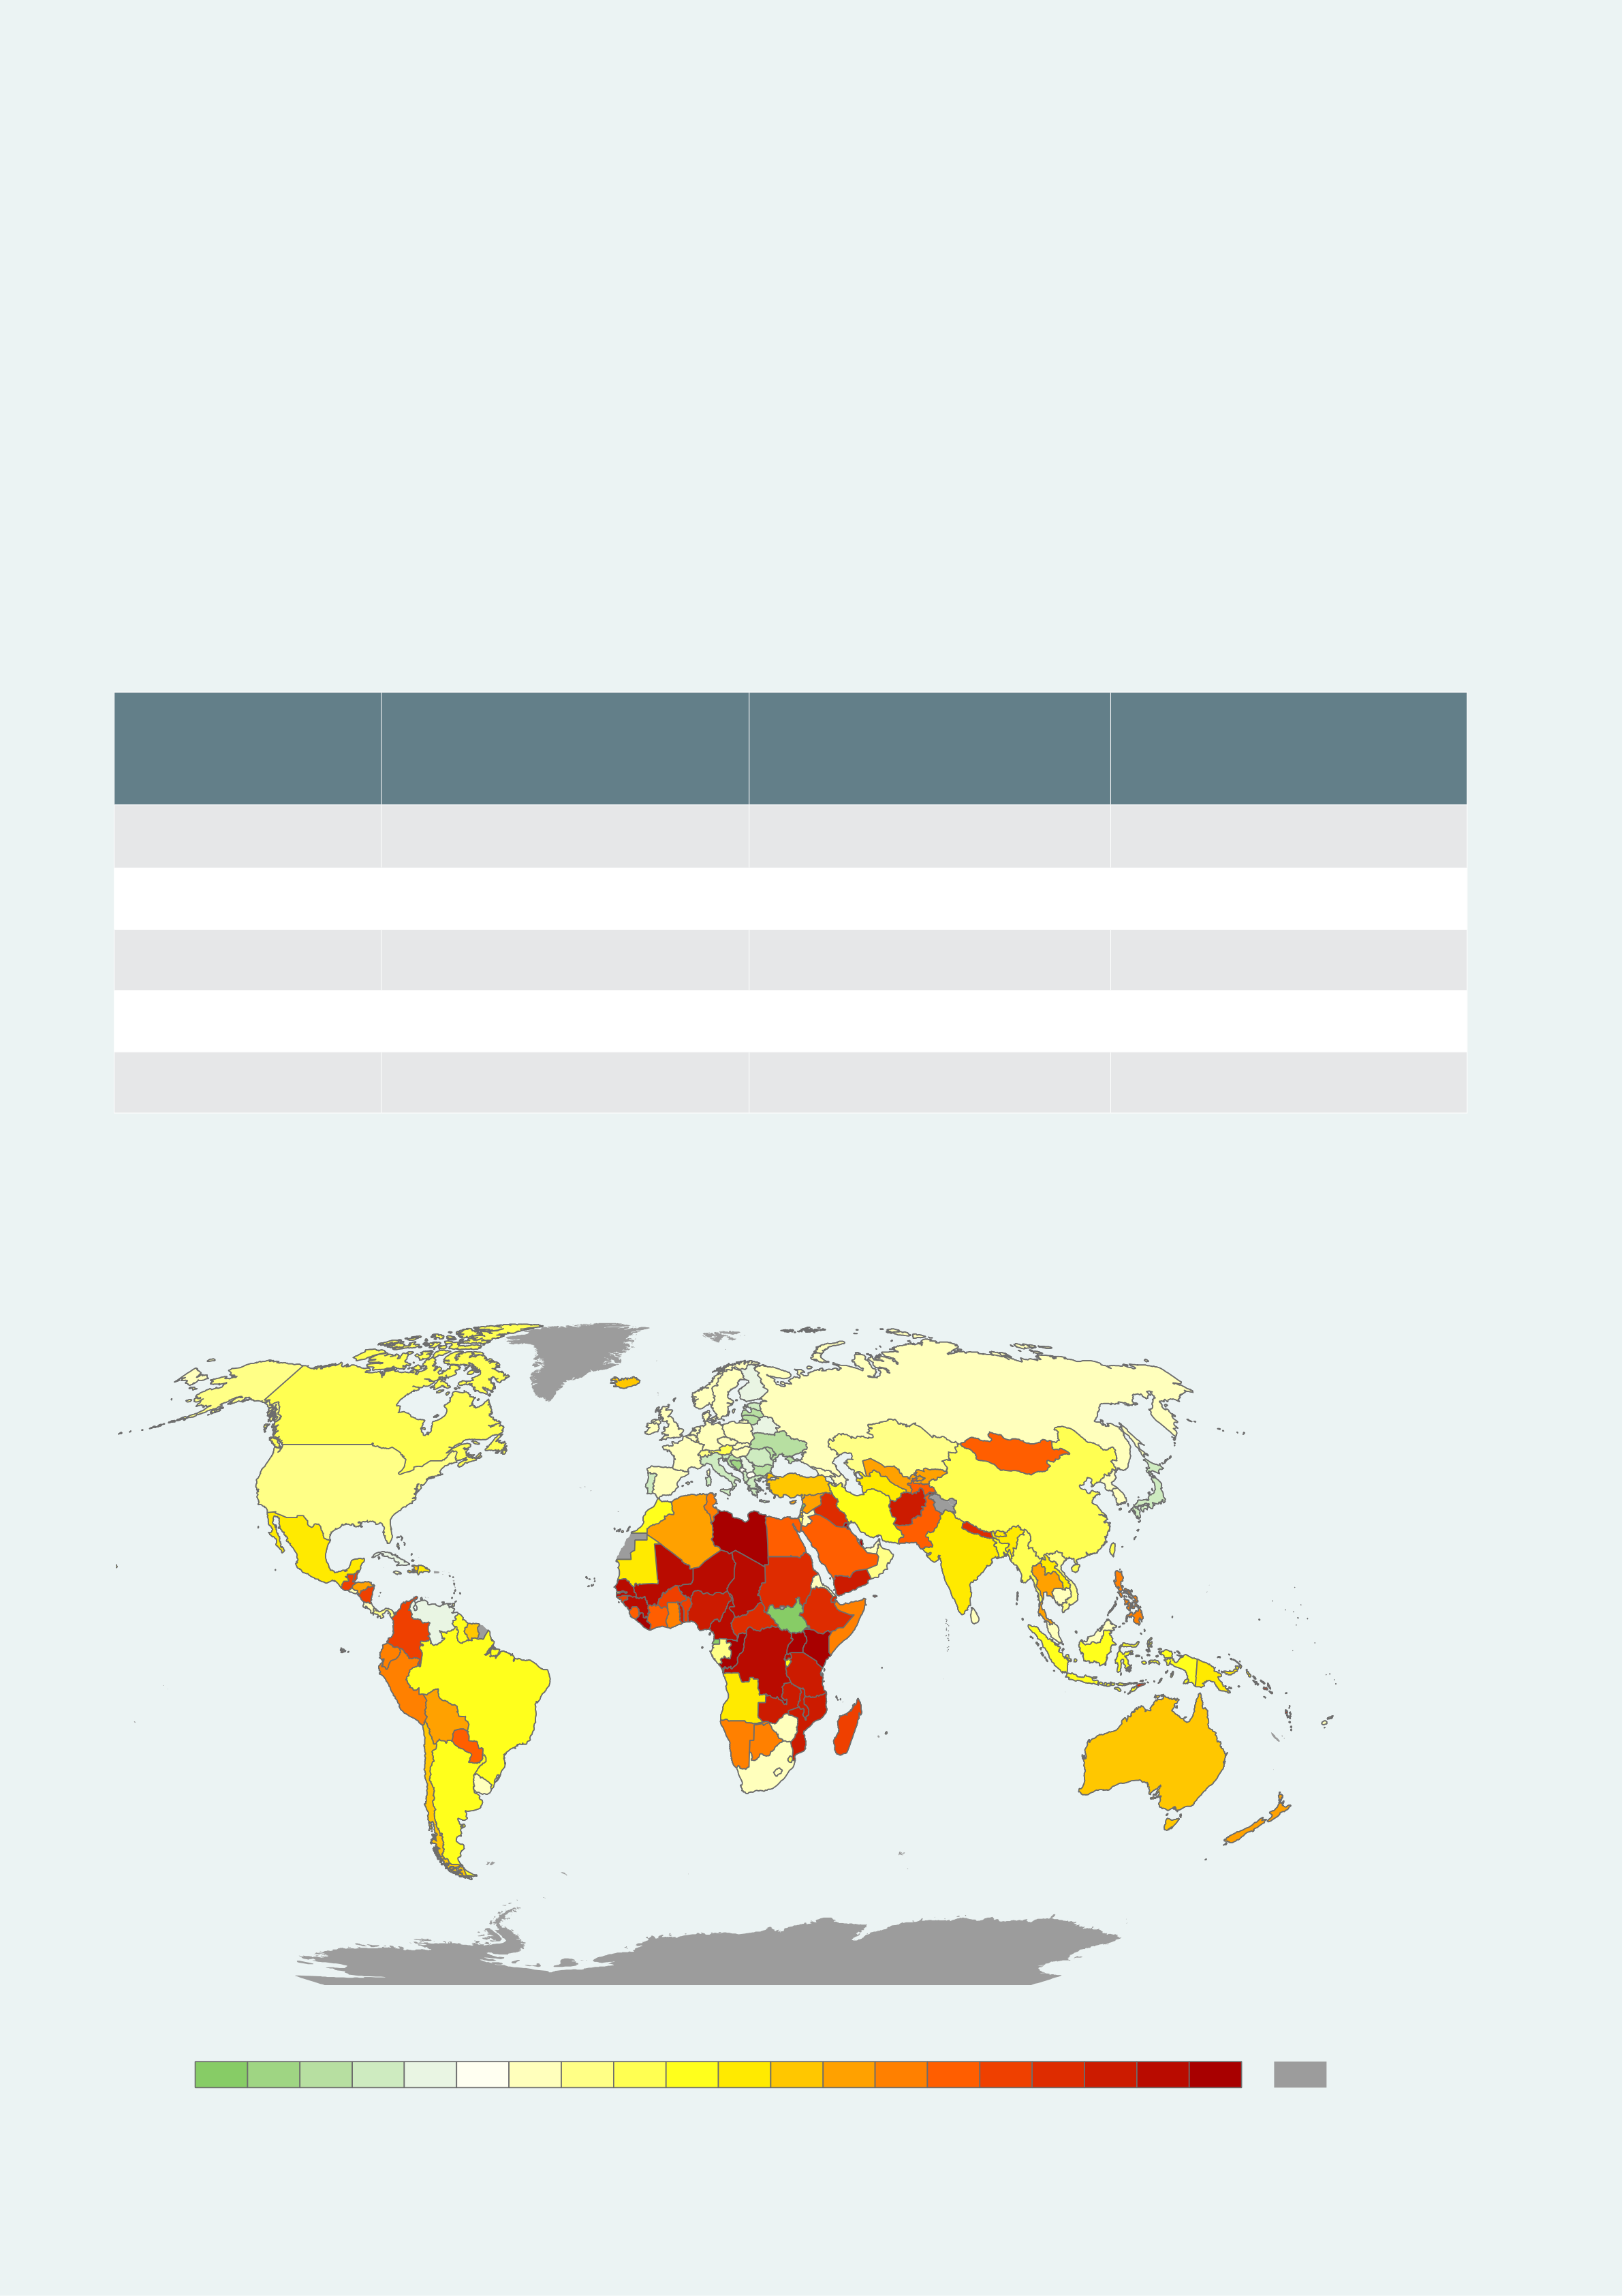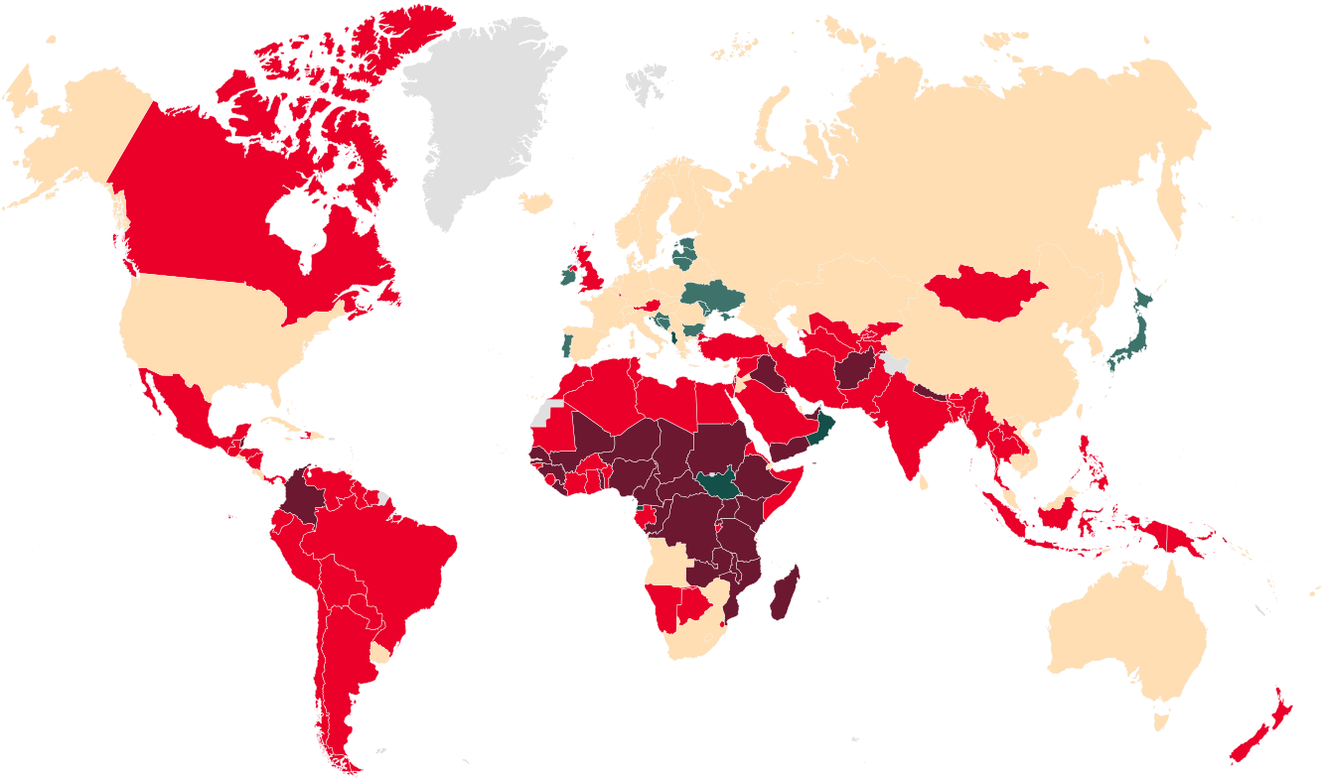

GLOBAL RISK TRENDS Exposure to natural hazards

EXPOSURE TO RIVER FLOODS

The largest overall exposure to river floods **Average annual exposed population to river flood**

|  |  |  |  |  |  |  |  |
| --- | --- | --- | --- | --- | --- | --- | --- |
| The incorporation of new natural hazard and multi-temporal exposure data into the INFORM Risk Index (see p14/15) allows | | | | is in Asia (southern and eastern Asia), | **(% change from 2015 to 2024)** | **River flood changes 2015-2024** | |
| us to analyse trends and patterns of exposure to sudden-onset natural hazards over the last 10 years. Average annual | | | | accounting for 66 million of those annually |
| Large decrease  Decrease  Stable | |
| exposure to sudden-onset natural hazards (river flood, coastal flood, cyclone, earthquake and tsunami) reached 184 | | | | exposed. The largest overall increase relative |
| million people in 2023 – an 8.6% increase since 2014. Climate-related hazards (river flood, coastal flood and cyclone) are | | | | to 2014 (21%) was in Africa (Middle and | |  | | --- | |  | | Increase |
| |  | | --- | |  | | Large increase |
| responsible for 95% of the absolute increases in exposure over the last 10 years. River and coastal floods combined account | | | | western Africa). | Not included in INFORM | |
| for an increase of 9.2 million in the number of people exposed annually, 62% of the total increase. Eastern, Southern and | | | | • More than 60% of the countries with large |
| South-eastern Asia has experienced the largest average annual exposure to sudden-onset hazards (78 million people per | | | |
| increases in flood exposure are classified as |
| year). Middle and Western Africa experienced the largest increase in average annual exposure in the last decade. | | | |
| high and very high risk countries. |
| **Hazard** | **Average annual exposed** | **Average annual exposed** | **Average annual exposed** | • Almost 90% of the countries classifies |
| as high and very high risk has experienced |
| **population (current, million)** | | **population (% change** | **population (absolute change** |
| increase in flood exposure. |
| **2015-2024)** | | | **2015-2024, million)** |
| River flood | 85 | 10.5 | 8.0 | • More than 60% of the very high risk |
| countries has experienced large increases in |
| Coastal flood | 16 | 8.0 | 1 .2 | flood exposure. |

• More than 70% of countries with large

|  |  |  |  |  |  |
| --- | --- | --- | --- | --- | --- |
| Cyclone (SS1) | 75 | 6.8 | 4.8 | increases in flood exposure are in Africa. | |
| Earthquake (MMI6) | 7 .5 | 9.5 | 0.64 | **River flood changes 2015-2024** • More than 80% of countries with large Large decrease  increases in flood exposure are low and lower Decrease | |
| Tsunami | 0.069 | 3.2 | 0.002 | middle income. | Stable |
| Increase | |

Large increase

Not included in INFORM

**Average annual exposed population to climate-related sudden-onset natural hazards (river flood, coastal flood, cyclone SS1) (% change from 2015 to 2024)**

**Average annual exposed population to river flood by sub-region (1000 people)**

|  |  |  |  |  |  |  |  |  |  |
| --- | --- | --- | --- | --- | --- | --- | --- | --- | --- |
| 37 | **%Change in combined exposure (river floods, coastal floods and cyclones)** | | | | | 30+ | No data |  | 38 |
| -15 | -5 | 0 | 10 | 20 |



INFORM is a collaboration of the Inter-Agency Standing Committee and the European Commission. The Joint Research Centre of the European Commission is the scientific and technical lead of INFORM. This report is based on the data available at   
https://drmkc.jrc.ec.europa.eu/inform-index.

This report is produced by the United Nations Office for the Coordination of Humanitarian Affairs on behalf of all INFORM Partners.

**INFORM Steering Group**

|  |  |  |  |
| --- | --- | --- | --- |
|  |  |  |  |
|  |  |  |  |
|  |  |  |  |

**INFORM Partners**

|  |  |  |  |  |
| --- | --- | --- | --- | --- |
|  |  |  |  |  |
|  |  |  |  |
|  |
|  |  |  |  |
|  |
|  |  |

For more information, go to <https://drmkc.jrc.ec.europa.eu/inform-index>

39

|  |
| --- |
| 40 |

